‘Blooming Shotley Bridge’ Portfolio - 2013

Introduction
The ‘Blooming Shotley Bridge’ sub committee was established in March 2010, following an open meeting of the Village Trust, which gave unanimous approval to the initiative. Although the members of the sub committee have been the prime drivers, all the members of the Trust and the wider community take part in discussions at the Trust’s open meetings, held 3 times a year.

We entered the village in the ‘Britain in Bloom Neighbourhood Award’ scheme in 2011 and were awarded Outstanding. The judge recommended that we enter the ‘Northumbria in Bloom’ competition, which we did in 2012 and were awarded Silver.

The area chosen for the competition is the same as in 2012, which includes most of the Shotley Bridge conservation area.

Names and Roles of Committee Members  Jeff Singleton [Chairperson]  Sue Shaw [Secretary]  Dulcie Elliott  Tim Harding  John Shaw  Clare Singleton  John Worters  Garth Johnson, treasurer of the Village Trust, looks after the accounts. | 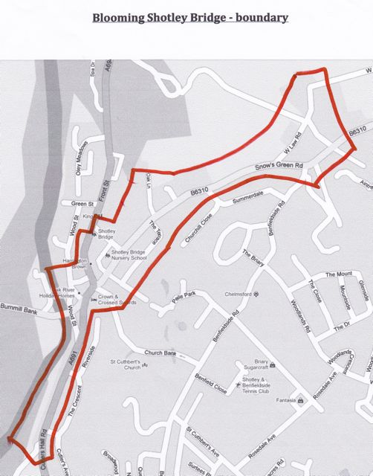

 | Policy & Strategy Plans |  |  |  |  |  |  |  |  |  |  |  |  | Judging  Criteria
 | The descriptions in this section incorporate the four essentials of horticulture, environment, sustainability and community, with the judging criteria identified on the right hand side.
 | In addition to the committee, over 35 members of the Village Trust, children and a local Brownie group are also volunteers with responsibility for a number of tubs including planting, watering, deadheading, weeding, maintenance and keeping the area tidy. Members of the committee manage the planting days, which are held twice a year, as well as covering for volunteers in their absence, e.g. holidays. With ‘Blooming Shotley Bridge’ being a sub-group of the Village Trust, this provides a structure and support network to ensure sustainability of the initiative. |  |  |  |  |  |  |  |  |  |  |  |  | A1/A2  C1/C3/C4
 | 25 volunteers, including children, assisted with the litter picks during the year and in some areas leaf clearing. The annual Spring ‘Litter Pick’ covers the whole village, not just the ‘Blooming Shotley Bridge’ area; including woodland, fields, the play park and riverside paths. Private areas such as the car park at the Crown & Crossed Swords are also cleared of rubbish.  Fly posting is notified to the County Council or taken down, whichever is the most appropriate. |  |  |  |  |  |  |  |  |  |  |  |  | A4/A5  B4  C1/C3/C4
 | 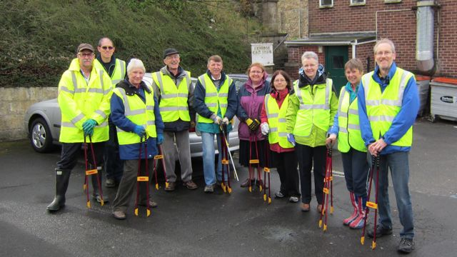 |  | 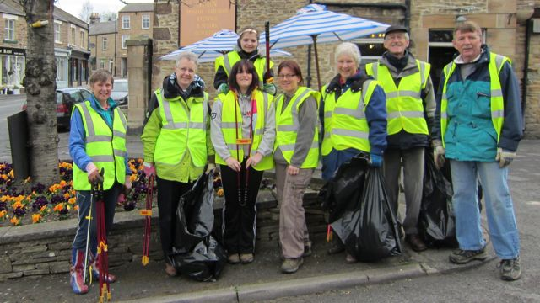 |  |  |  |  |  |  |  | 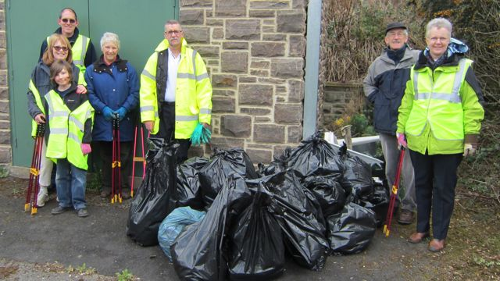
 | 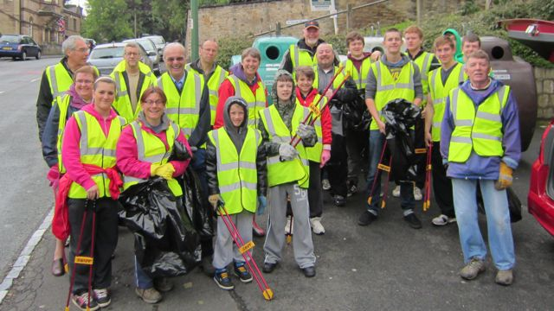 |  | 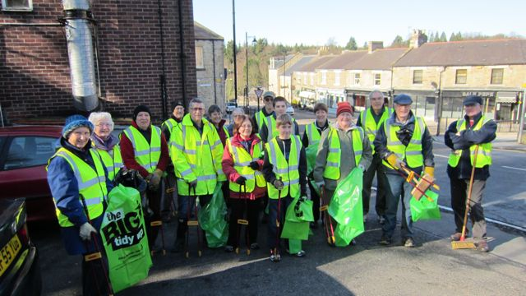 |  |  |  |  |  |  |  | 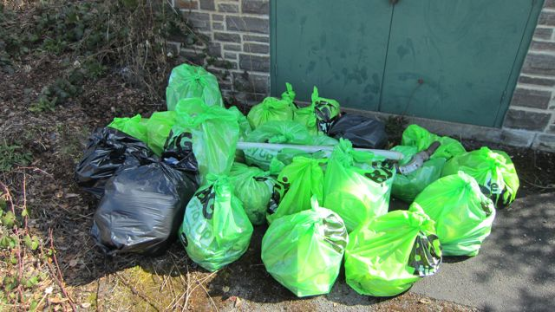
 | Initially we purchased fifty tubs and a trough, similar in size and appearance to a water trough that was used by horses in ‘days gone by’. The Village Trust volunteers plant the trough and the tubs. We have also bought 8 barrier baskets, which are currently planted by Durham County Council.  In the past we have used daffodils and winter pansies in the tubs, trough and barrier baskets. This spring we decided to try something different. Violas and three varieties of miniature daffodils, which would flower at different times, were planted in the tubs last autumn. In hindsight, using different bulbs was not a good idea, as the impact was not as good as having them all flowering at the same time. The trough is now filled with sustainable plants. |  |  |  |  |  |  |  |  |  |  |  |  | A1/A2/A3  B3  C1/C4/C5
 | 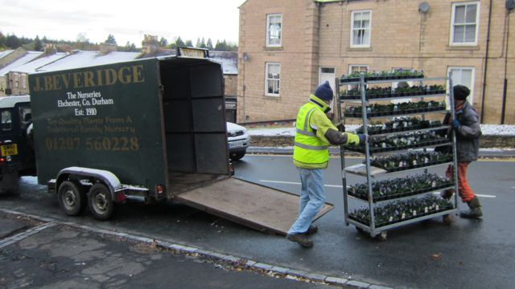 |  | 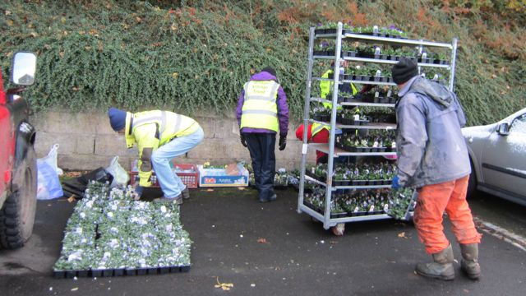 |  |  |  |  |  |  |  | 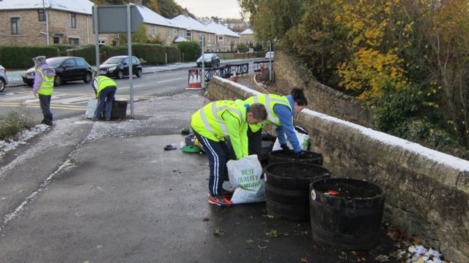
 | 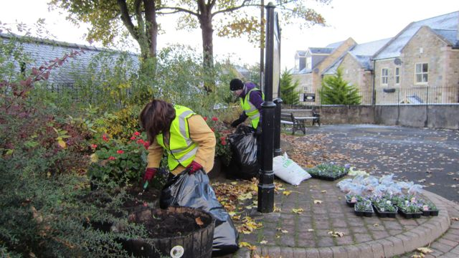 |  | 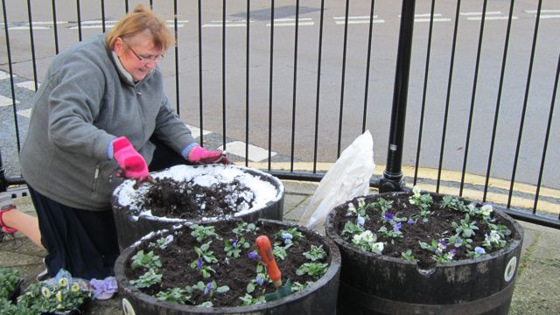 |  |  |  |  |  |  |  | 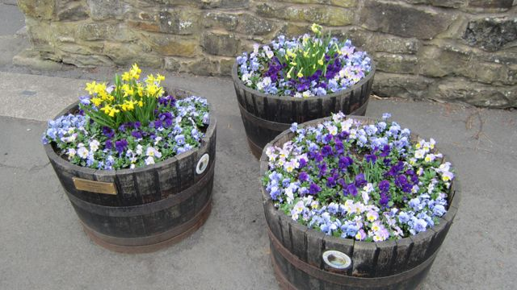
 | 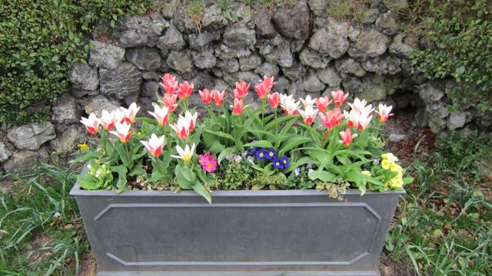 |  | 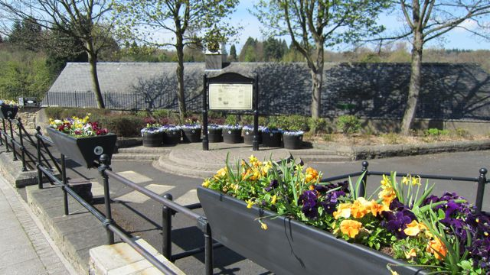 |  |  |  |  |  |  |  | 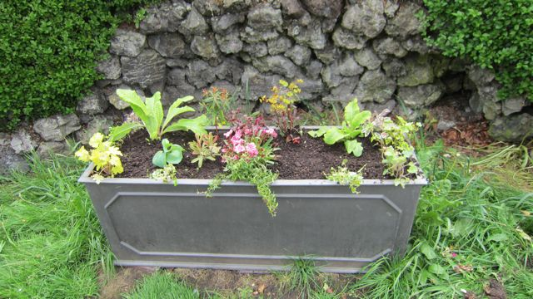
 | In the past we have planted crocus and daffodil bulbs in grassed areas, including the area around the water trough. These continue to provide colour each year. By taking photographs, we identify the gaps where bulbs can be planted in the future. The daffodil bulbs given to the Junior School were used to create a ‘smiley face’ in 2011 and a ‘school shield’ in 2012 in the grassed areas in front of the building. This year the daffodil bulbs have been dried, to be re-planted in grassed areas in the autumn. As the violas were still in full flower when replaced by the summer bedding, it was decided to replant as many as possible at the Junior School, with the help of the school children. Some were also planted at the Catholic Church and in a roadside verge. We intend pruning them to encourage flowering for a second season. As the King’s Restaurant is still closed, it was decided to plant the window box, as we did last year. We have kept the plants in the window box for now. |  |  |  |  |  |  |  |  |  |  |  |  | A1/A2/A3  A4/A5  B2/B4  C1/C4
 | 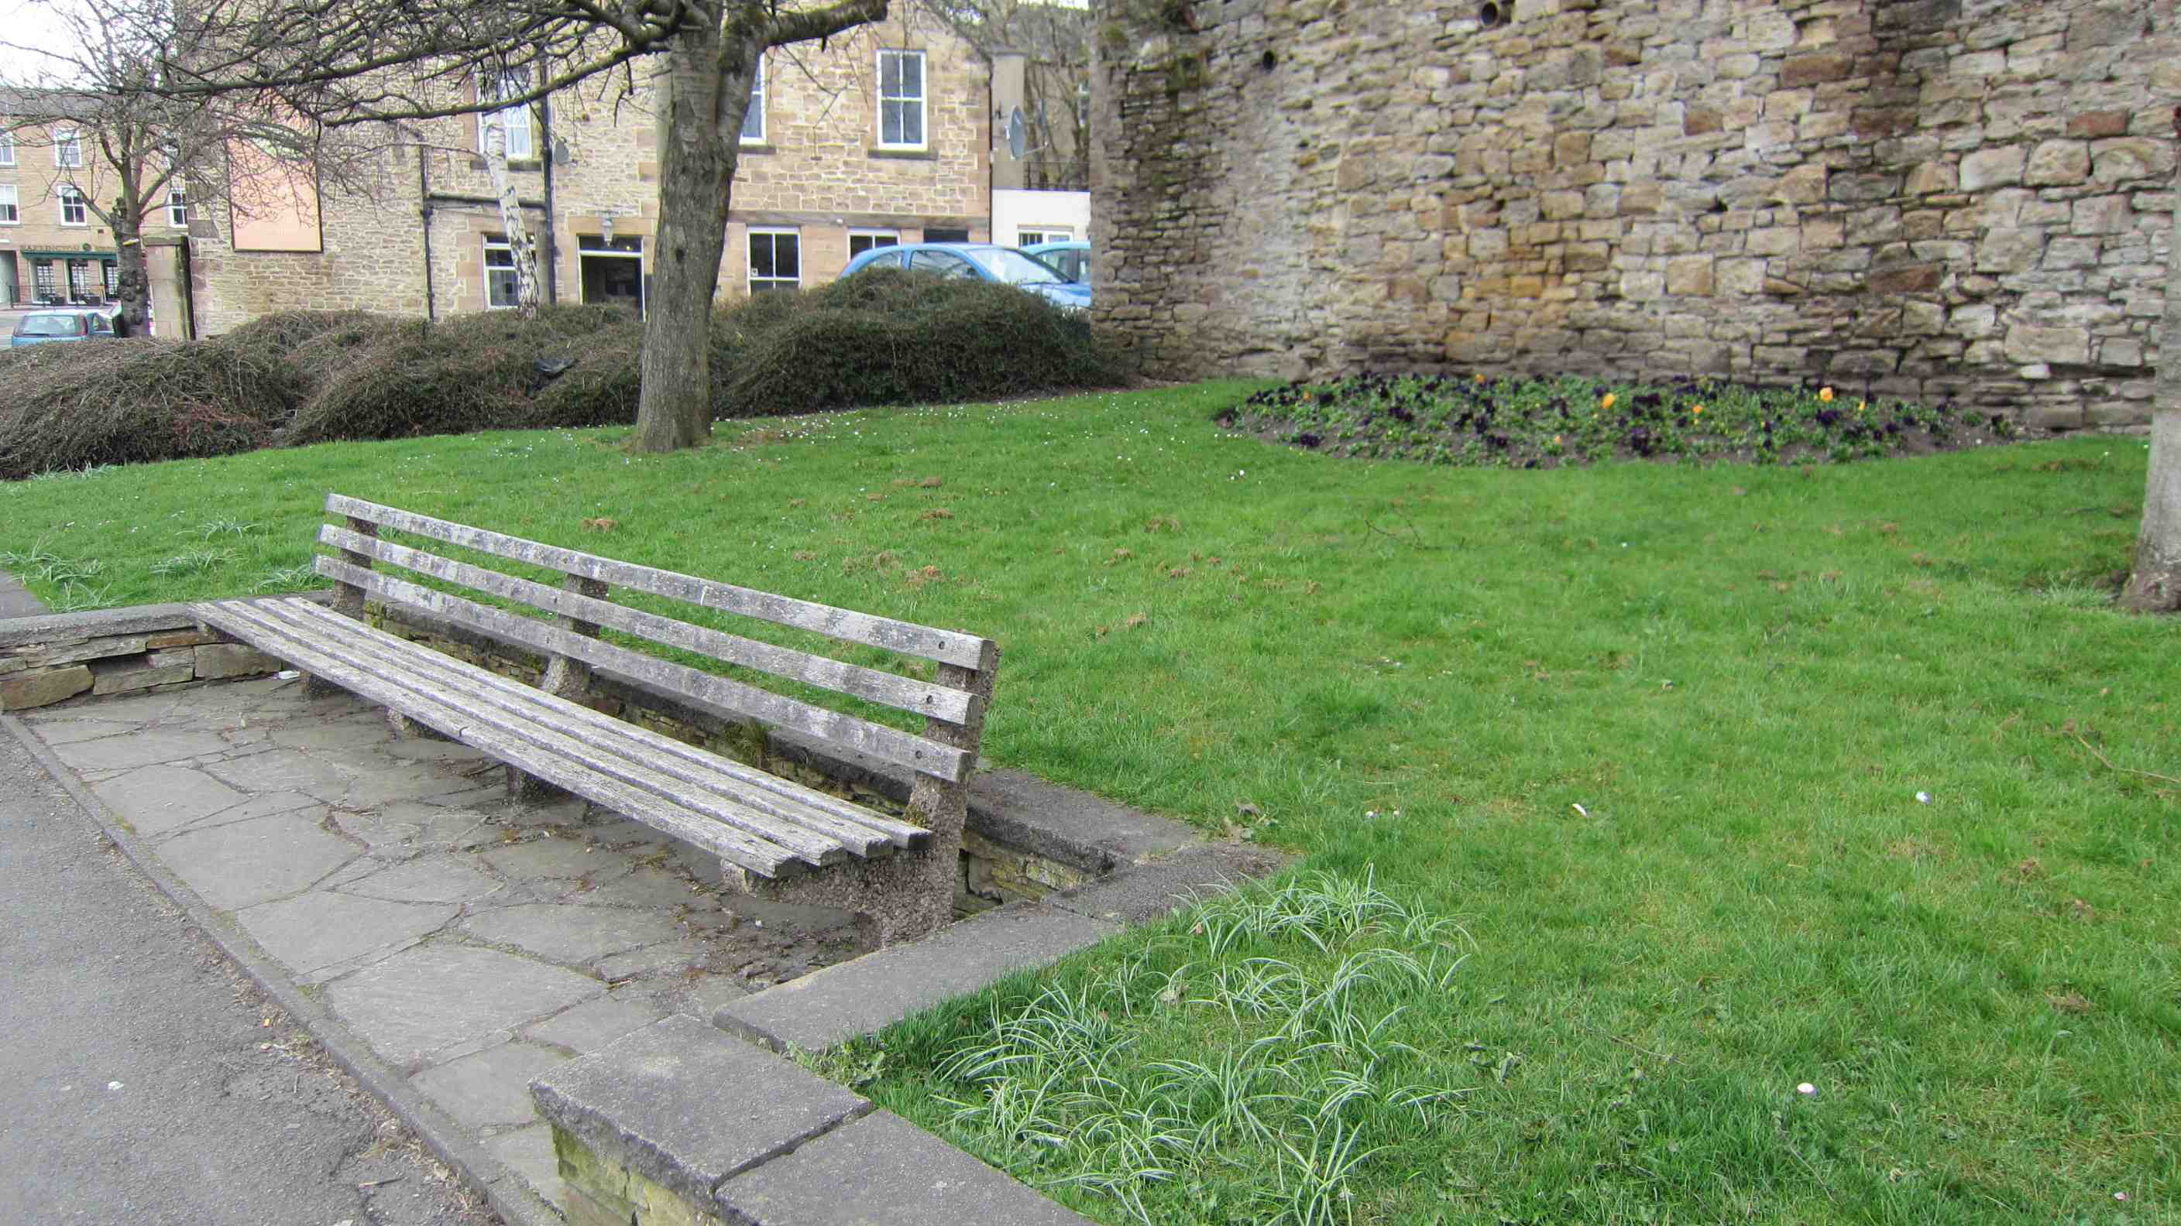 |  |  | 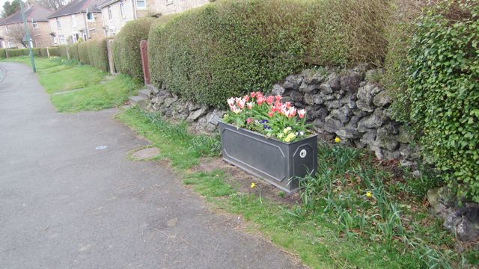 |  |  |  |  |  |  | 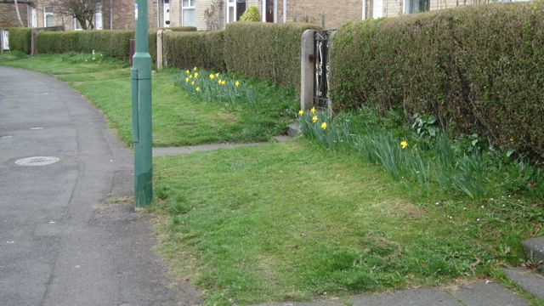
 | 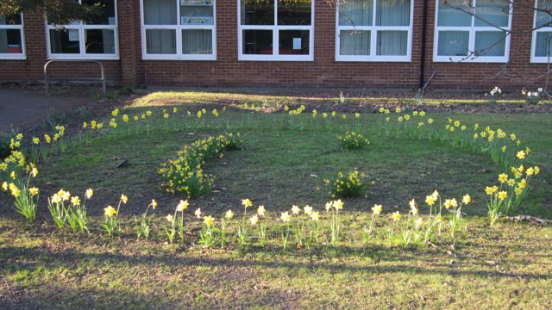 |  |  |  |  |  |  | 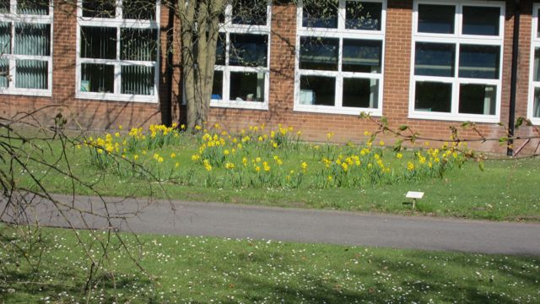
 | 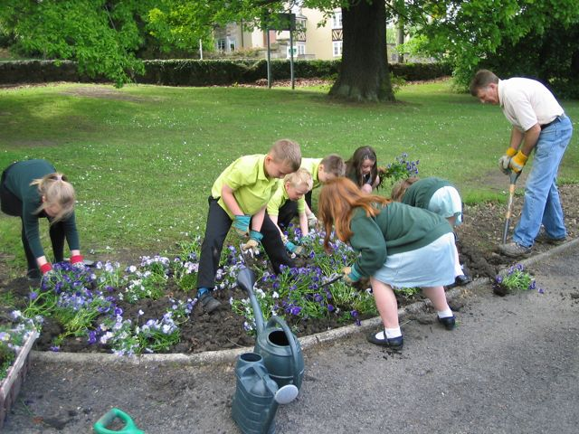 |  | 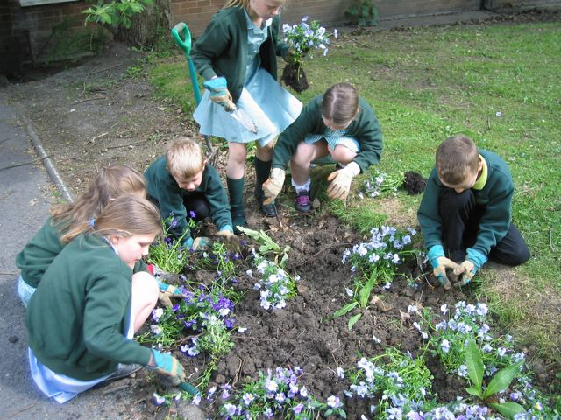 |  |  |  |  |  |  |  |  | 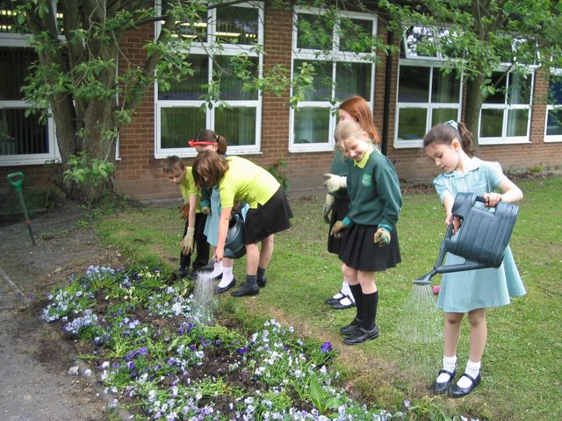
 | 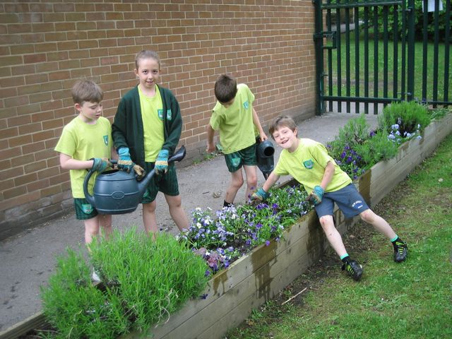 |  | 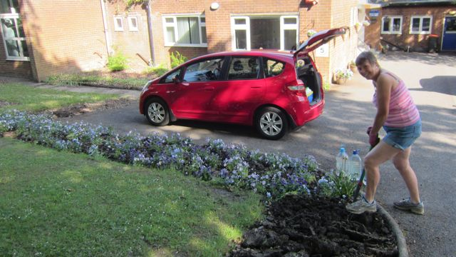 |  |  |  |  |  |  |  |  | 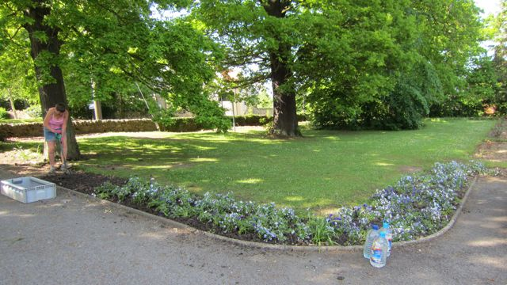
 | 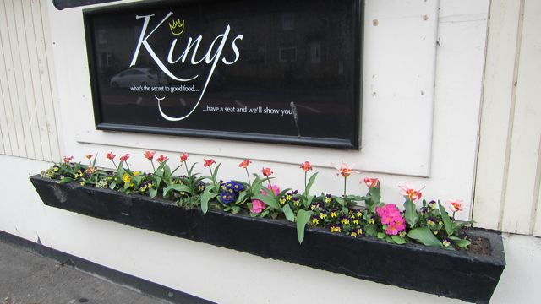 |  |  |  |  |  |  | 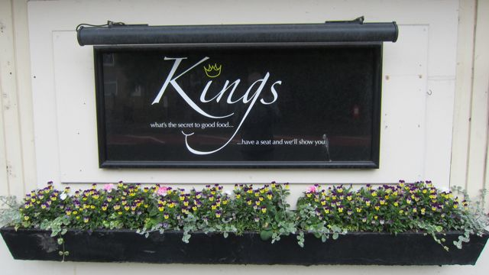
 | Removed plants are all composted locally. The compost is recycled to improve the soil condition in the tubs and other planted areas. Recycled milk containers are used for watering the tubs, barrier baskets and trough.  All the planters provided by the Village Trust have been badged with its logo.  Commemorative plaques have been attached to the tubs that were looked after last year by two of our volunteers, who have recently died.  Thinking about a theme for this summer, one of our committee members suggested a white, pink and blue colour scheme to celebrate the birth of the royal baby in July. This was greeted with enthusiasm. A press release was sent for inclusion in the local AAP newssheet. For the planting layout of the tubs we chose a white geranium for the centre, then a ring of 3 pale pink geraniums and 3 pink begonias and finally a ring of alternating Cambridge blue and white lobelia. Begonia plants with the small flowers were ordered, but ones with the larger flowers were delivered. Initially we were rather disappointed, but now we are pleased, as the colour of the large flowers is more prominent and has a greater impact before the lobelia came into flower.  While discussing maintenance and planting with the county council, we were initially informed that the council’s decision [last November] was to plant the beds and the barrier baskets in orange, which obviously didn’t complement our colour scheme. We were delighted to find the barrier baskets planted in white, pink and blue which now complement the tubs. We also planted the window boxes at the Crown & Crossed Swords and hanging baskets in front of the Kings restaurant.  We are still looking into various options to ease the problem of transporting water for watering the plants. We ordered one H2go wheelbarrow water carrier bag to try, but it has proved unsuitable.  Since the spring judging volunteers have painted all the tubs black using one type of paint for the wood and another for the metal rings. Some of the businesses’ tubs were also painted. |  |  |  |  |  |  |  |  |  |  |  |  | A1/A2/A4  B2/B5  C2/C3/C4
 | 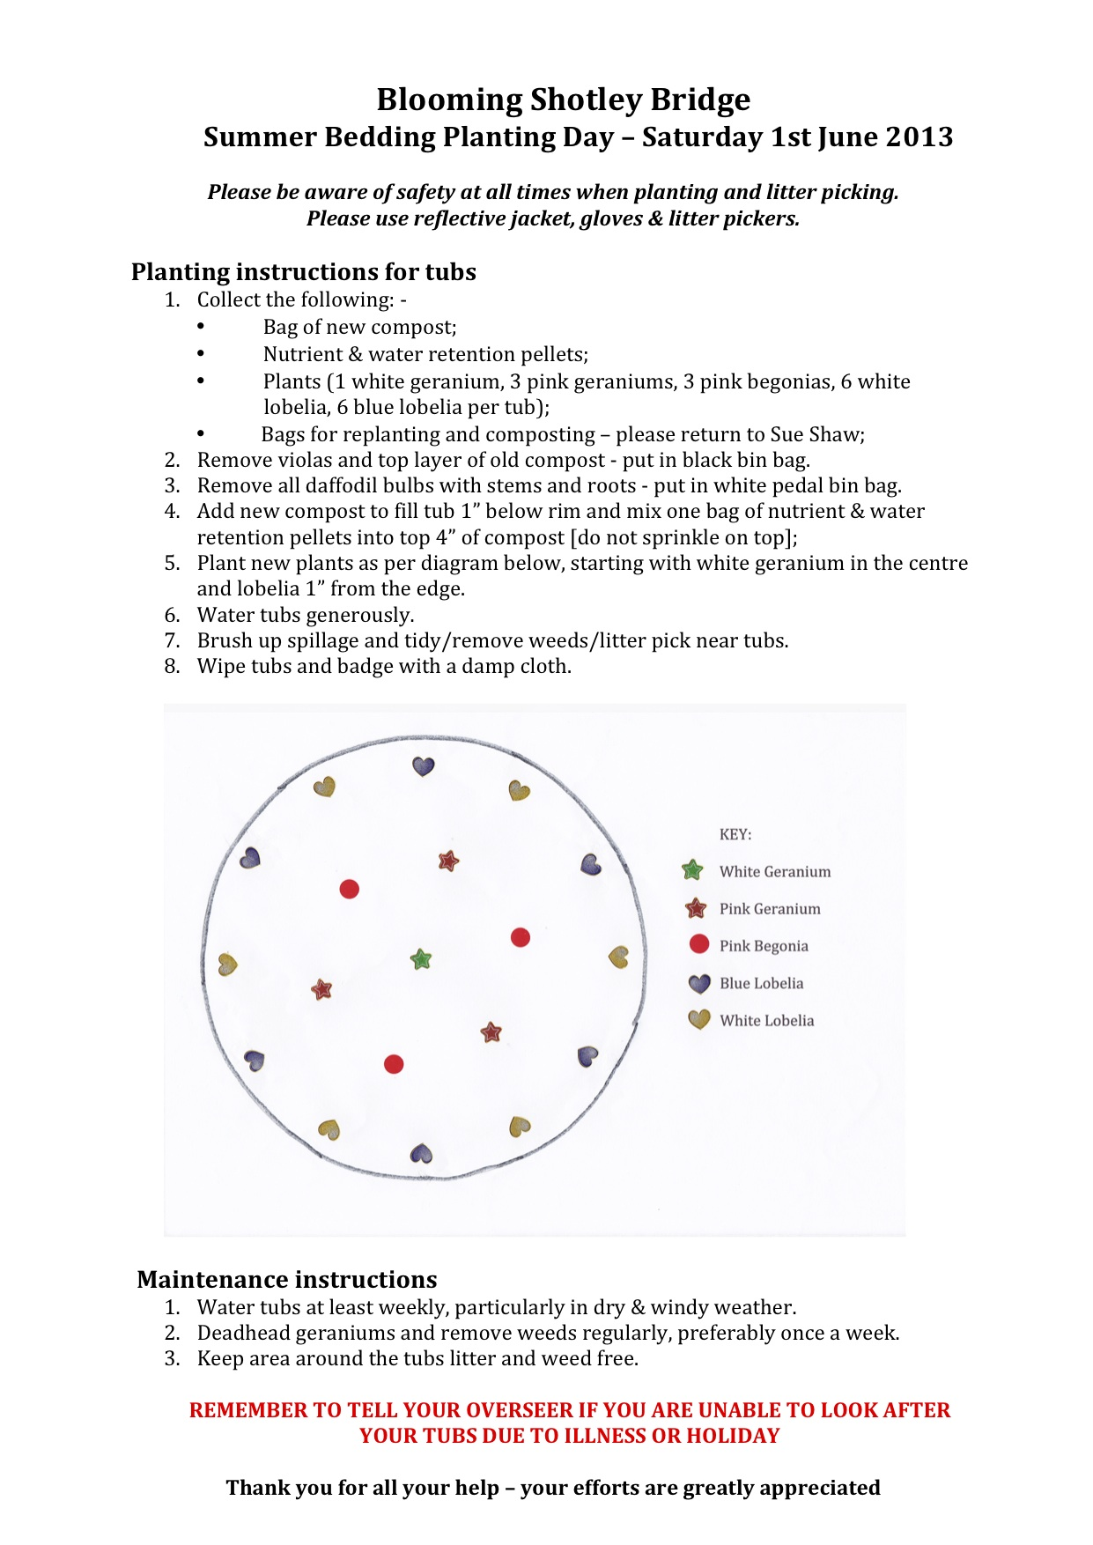 |  |  |  | 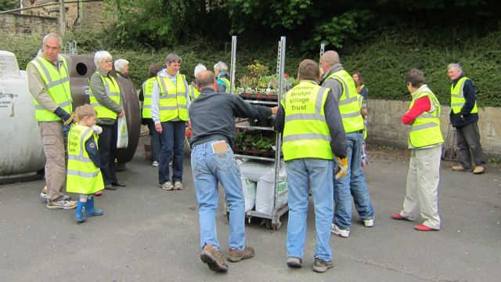 |  |  |  |  |  |  | 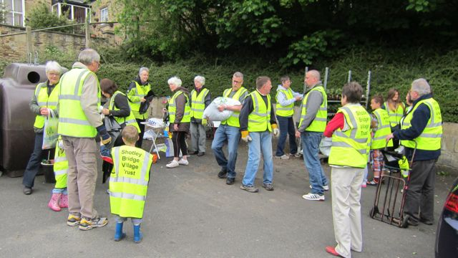
 |  |  |  |  | 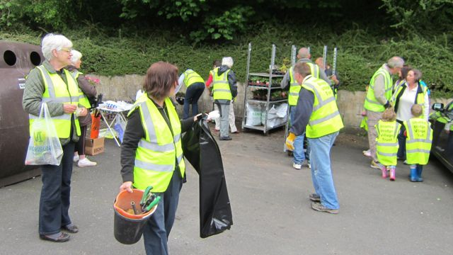 |  |  |  |  |  |  | 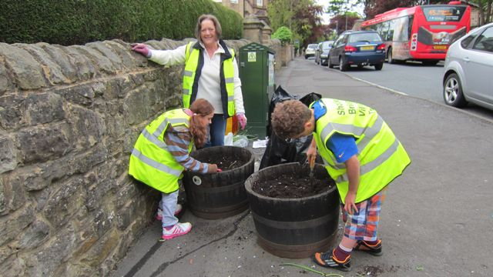
 | 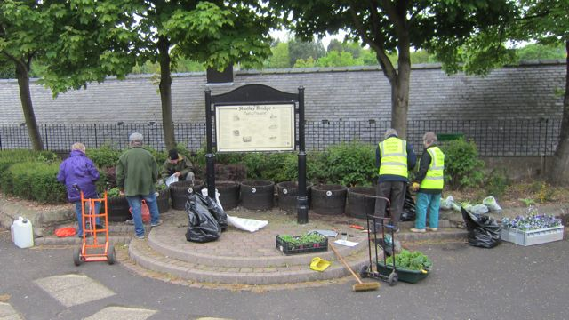 |  |  | 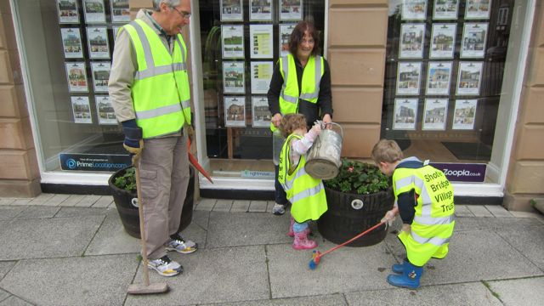 |  |  |  |  |  |  | 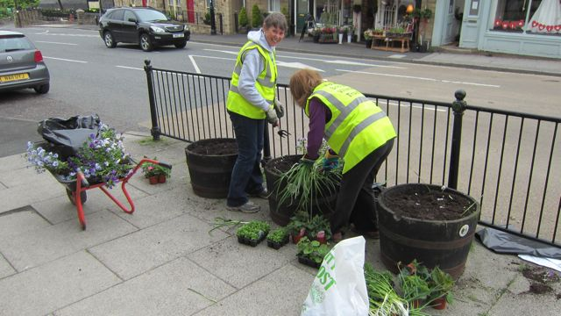
 | 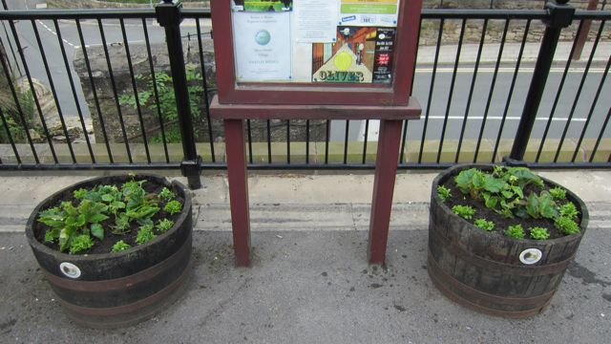 |  |  | 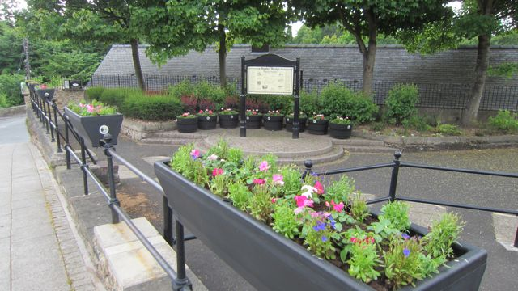 |  |  |  |  |  |  | 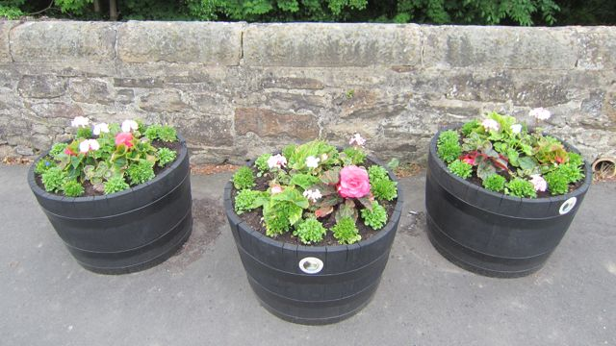
 | 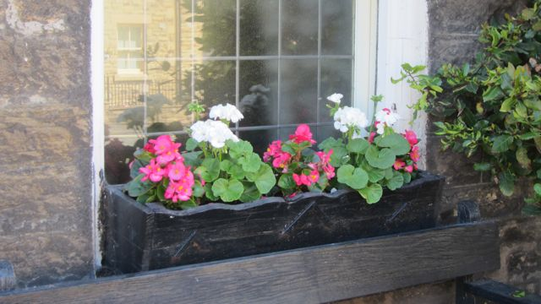 |  |  | 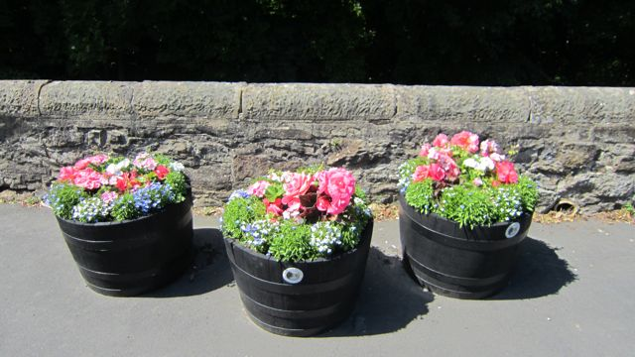 |  |  |  |  |  |  | 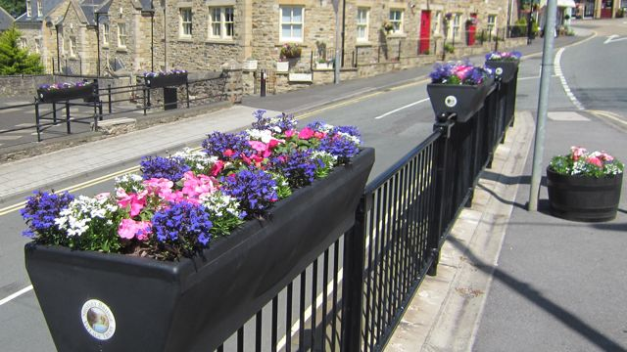
 | 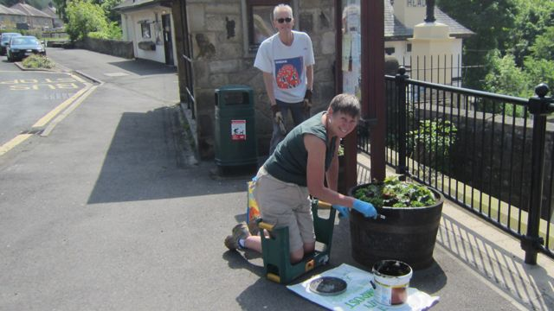 |  |  | 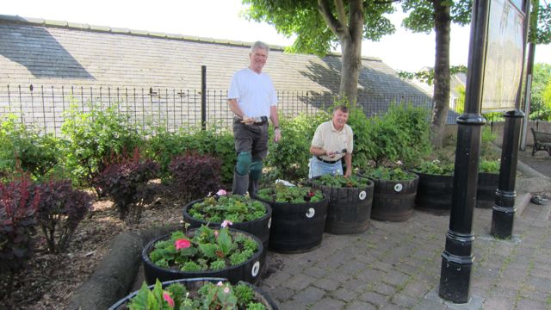 |  |  |  |  |  |  | 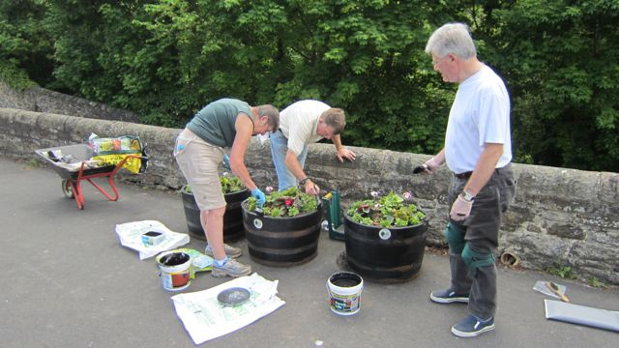
 | Numerous discussions have taken place with the council about the shrub bed at the back of the ‘Triangle’. We asked for the rose bushes to be removed, a layer of nutritious soil to be added and new berberis shrubs to be planted, matching the two varieties that were already there. Disappointingly, only a little soil improver was added around the new berberis plants and only a single variety was planted. Volunteers have added extra plants from their own gardens to improve the ground coverage, which were looked on favourably by the council, so long as we let them know what we don’t want disturbing.  The Council plants the three flowerbeds in the centre of the village twice a year. Since the spring judging we have met with the council about taking over one of the beds (opposite the Kings restaurant, in front of the stone wall), and filling it with sustainable plants instead of the usual spring and summer bedding plants. This has been agreed, but we were advised to wait until the autumn, which would be a more suitable time to plants shrubs. Various species are presently being considered. One is Viburnum ‘Eve Price’, which provides flowers periodically throughout the year and we have taken cuttings to create our own plants. Another suggestion was Photinia ‘Red Robin’, which is suitable in either sun or shade and provides interest with colourful red leaves. As well as being an attractive plant for years to come, it will add significance next year when the theme we are considering is the commemoration of the start of World War 1. Our local nursery owner, John Beveridge, also suggested pieris, laurel, miniature fir trees, and viburnum ‘Tinus’, which is taller than ‘Eve Price’. For ground cover he said we could consider using cranesbill geranium, which would give a lot of colour in the summer even though it dies back in winter.  We are also looking into erecting a replica of the drinking fountain that used to be in the centre of the village, which is now at Beamish Museum, which could be placed near the sustainable border. We visited Beamish where staff showed us the historical records and gave us advice. If possible we would like to have a tap behind the pant, which would help volunteers with their ‘watering duties’. The original pant has four stone bowls, with each one containing a drinking fountain. Our intention would be to use these for floral displays. |  |  |  |  |  |  |  |  |  |  |  |  | A1/A2  B3  C1
 | 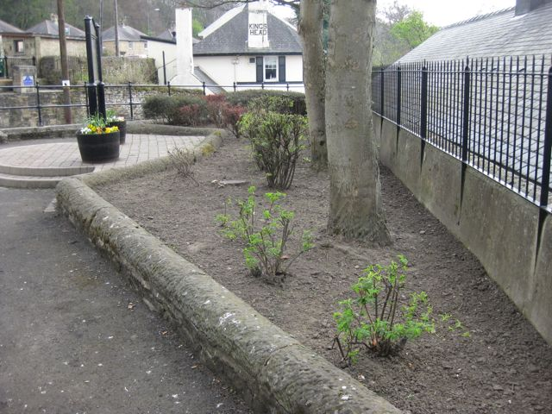 |  |  |  |  |  |  | 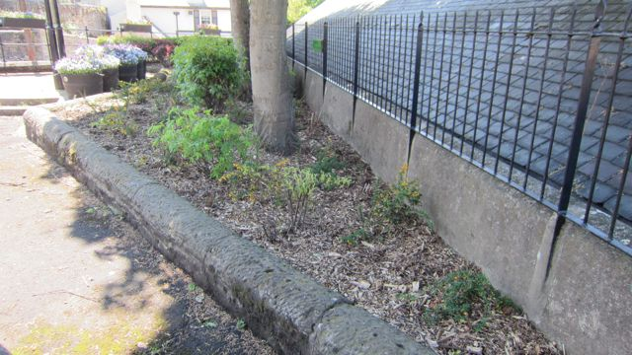
 | 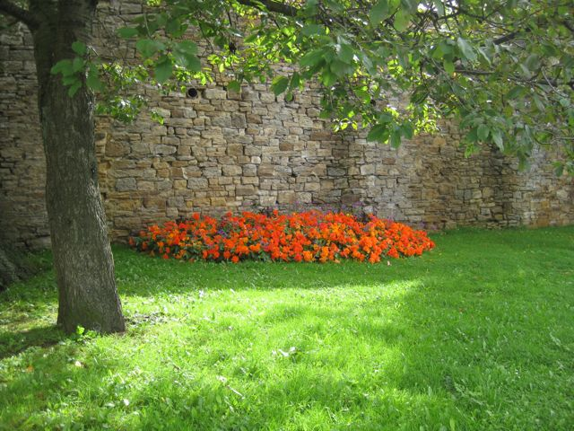 |  |  | 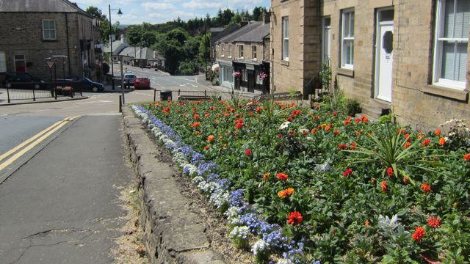 |  |  |  |  |  |  | 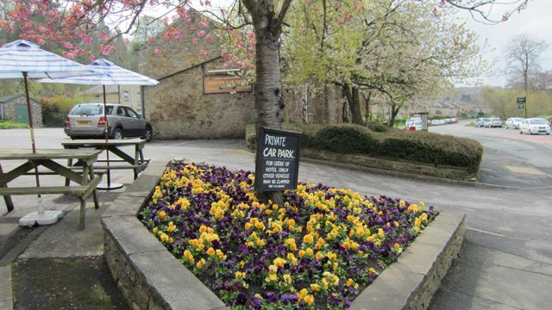
 | The council has agreed to replant the rose bed at the junction of Benfieldside Road and Snows Green Road with sustainable plants when funding becomes available, to which the Trust will make a contribution. We have been concerned for a while about the trees overhanging the bed and therefore shading the plants. With the agreement of the occupant who owns the trees, the council has agreed to trim them. |  |  |  |  |  |  |  |  |  |  |  |  | A1/A2  C1/C5
 | 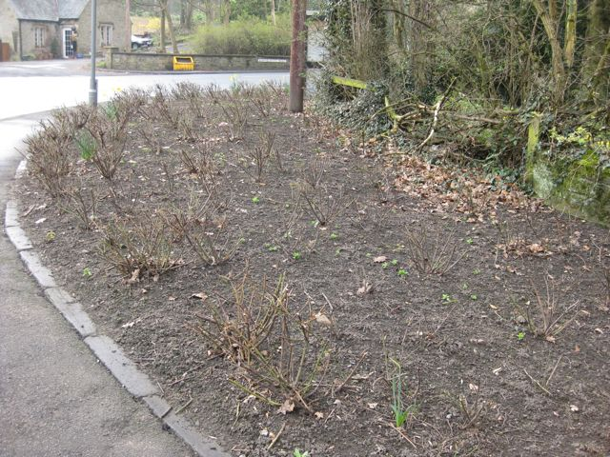 |  | 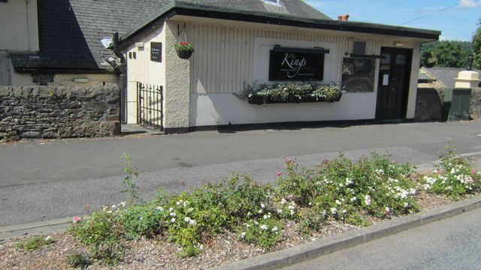 |  |  |  |  |  |  |  |  | 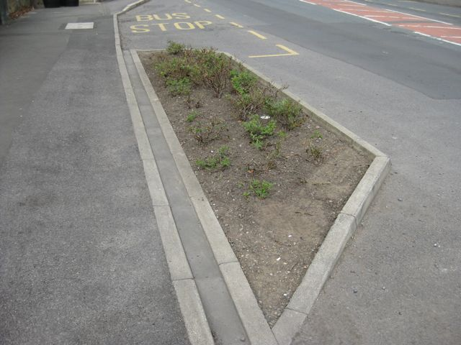
 | Members of the Blooming Committee have met officers of the County Council to discuss the list of potential urban realm improvements to the village centre that was discussed at last November’s open meeting of the Village Trust. £125,000 is being provided, as part of the Section 106 funding, from the new housing development on the former Shotley Bridge Hospital site. The council has produced plans for five of the suggestions, which were discussed at the last Village Trust open meeting in June. Prices for other schemes are still awaited before decisions can be made on where the money will be spent. Hopefully, the rose beds in front of the Kings restaurant can be redesigned as part of the S106 funding. |  |  |  |  |  |  |  |  |  |  |  |  | B3  B5  C1/C5
 | 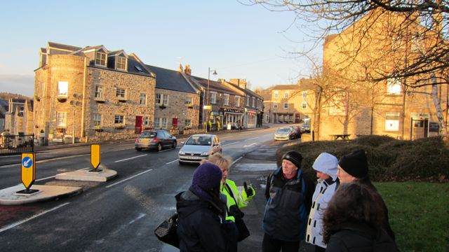 |  | 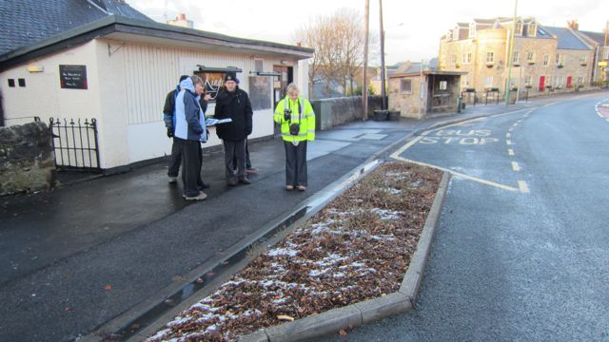 |  |  |  |  |  |  |  | 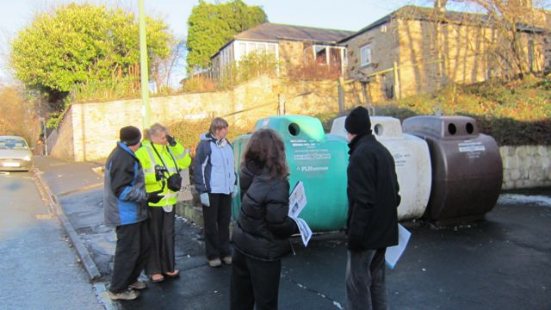
 | A local nursery garden, Beveridges, renowned for growing good quality plants, supplies our summer and winter bedding at competitive rates. They can be relied on to give sound, appropriate advice about the suitability of different plants, when to plant, feeding etc. The majority of the compost we use is produced by the nursery and is made up of 50% sterilized soil, a proportion of which is recycled. Volunteers also supply compost from their own gardens. Slow release granular fertiliser and water retention gel is used in both the winter and summer planting. By using a local supplier who grows his own bedding plants who is only 2 miles from the village, helps maximize sustainability. |  |  |  |  |  |  |  |  |  |  |  |  | A1/A2/A4  B2  C5
 | Briary Garden Services (a business member of the Trust) voluntarily cuts the hedge and grass around the trough and strims Kiln Bank as and when required, which has improved the overall look of what were two problematic areas. |  |  |  |  |  |  |  |  |  |  |  |  | A2  C1/C5
 | 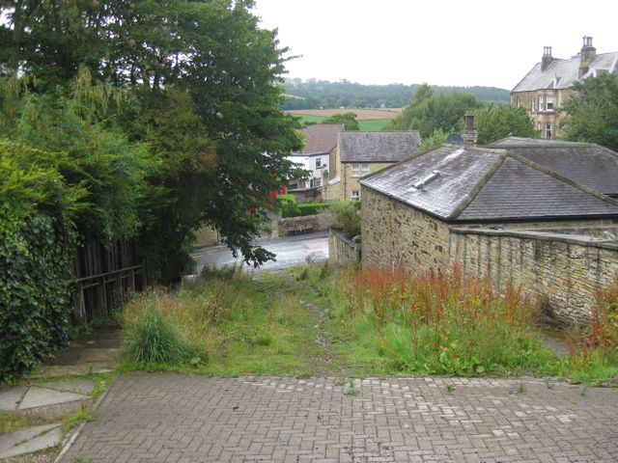 |  |  |  |  |  |  |  | 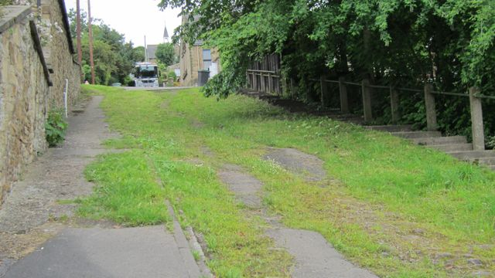
 | Excellent links have been developed with local businesses in the village, through the Shotley Bridge Business and Community Partnership, with most of the businesses providing and maintaining tubs and hanging baskets outside their premises. Closer links have been developed with the Crown and Crossed Swords PH and Kings Head Social Club with assistance being given to the planting of window boxes and hanging baskets. The owner of the Club is currently refurbishing this important listed building and intends to create a welcoming floral decoration next to the County Durham entry sign. Hopefully the hanging basket competition for businesses, with the offer of a 15% discount from Beveridges, will encourage most of the businesses to participate. |  |  |  |  |  |  |  |  |  |  |  |  | A1/A2/A4  C1/C3/C5
 | 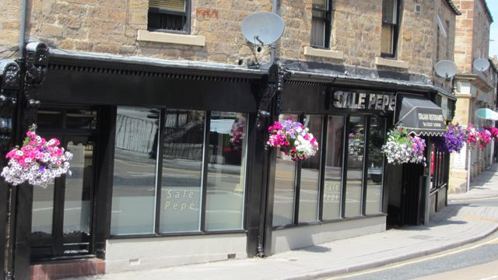 |  |  | 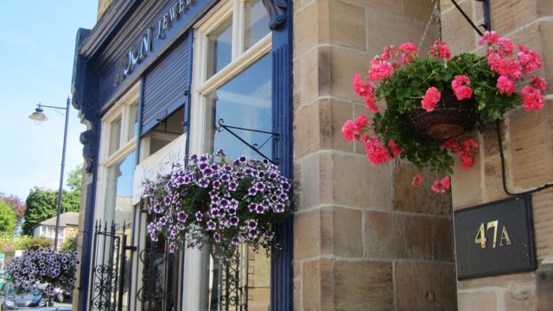 |  |  |  |  |  |  | 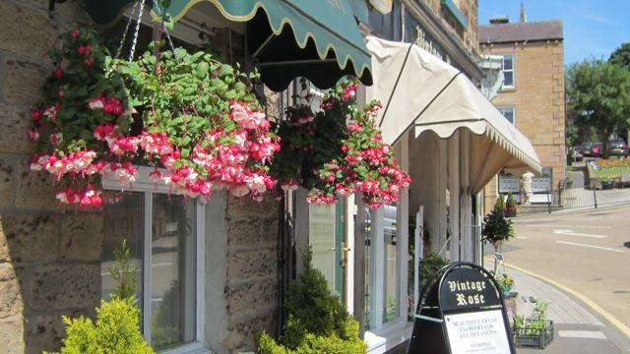
 | As well as replanting the daffodil bulbs and violas, Shotley Bridge Junior School have an ‘After School’ club, where children have the opportunity to be involved in gardening projects. The children are also creating a conservation area at the back of the school, encouraging habitat for wildlife. Everything that is cut down on site is used for other purposes within the site. Volunteers from the Village Trust helped to create the site including the outside auditorium and classrooms within it. They still make regular visits to help with maintenance and the continued development of the site. A camera shows the children the different types of wildlife that are using the area. Excellent links have been developed with the staff at the school, which has been helped by the fact that one member of the ‘Blooming Shotley Bridge’ committee teaches there occasionally. Presentations have been given both to the children and the parents telling them about the relevant activities within the school and their links with ‘Blooming Shotley Bridge’. Another member of the committee donated snakeshead fritillary seeds (latin name - fritillaria meleagris) from her own wildlife garden to sow on the site. As mentioned previously the winter violas re-planted in the school grounds have added an extra bit of colour and interest to unplanted beds at the main entrance. |  |  |  |  |  |  |  |  |  |  |  |  | A1/A2A3  B1/B2  C1/C2/C3
 | 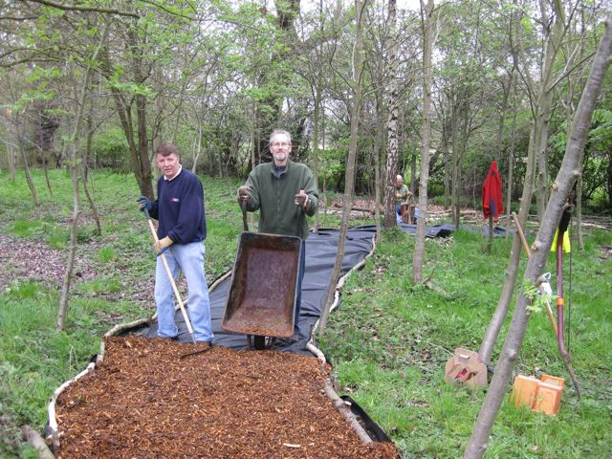 |  |  | 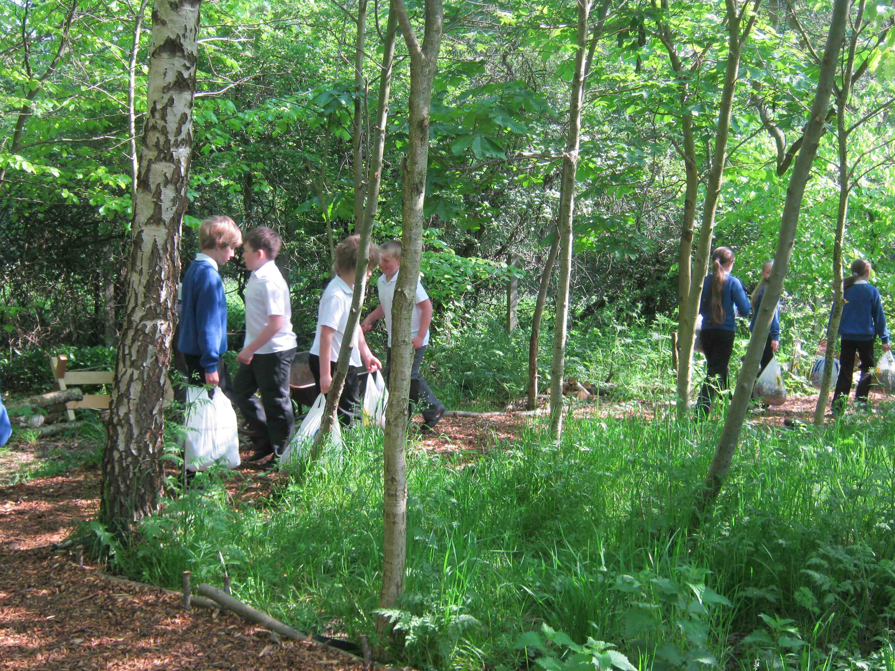 |  |  |  |  |  |  | 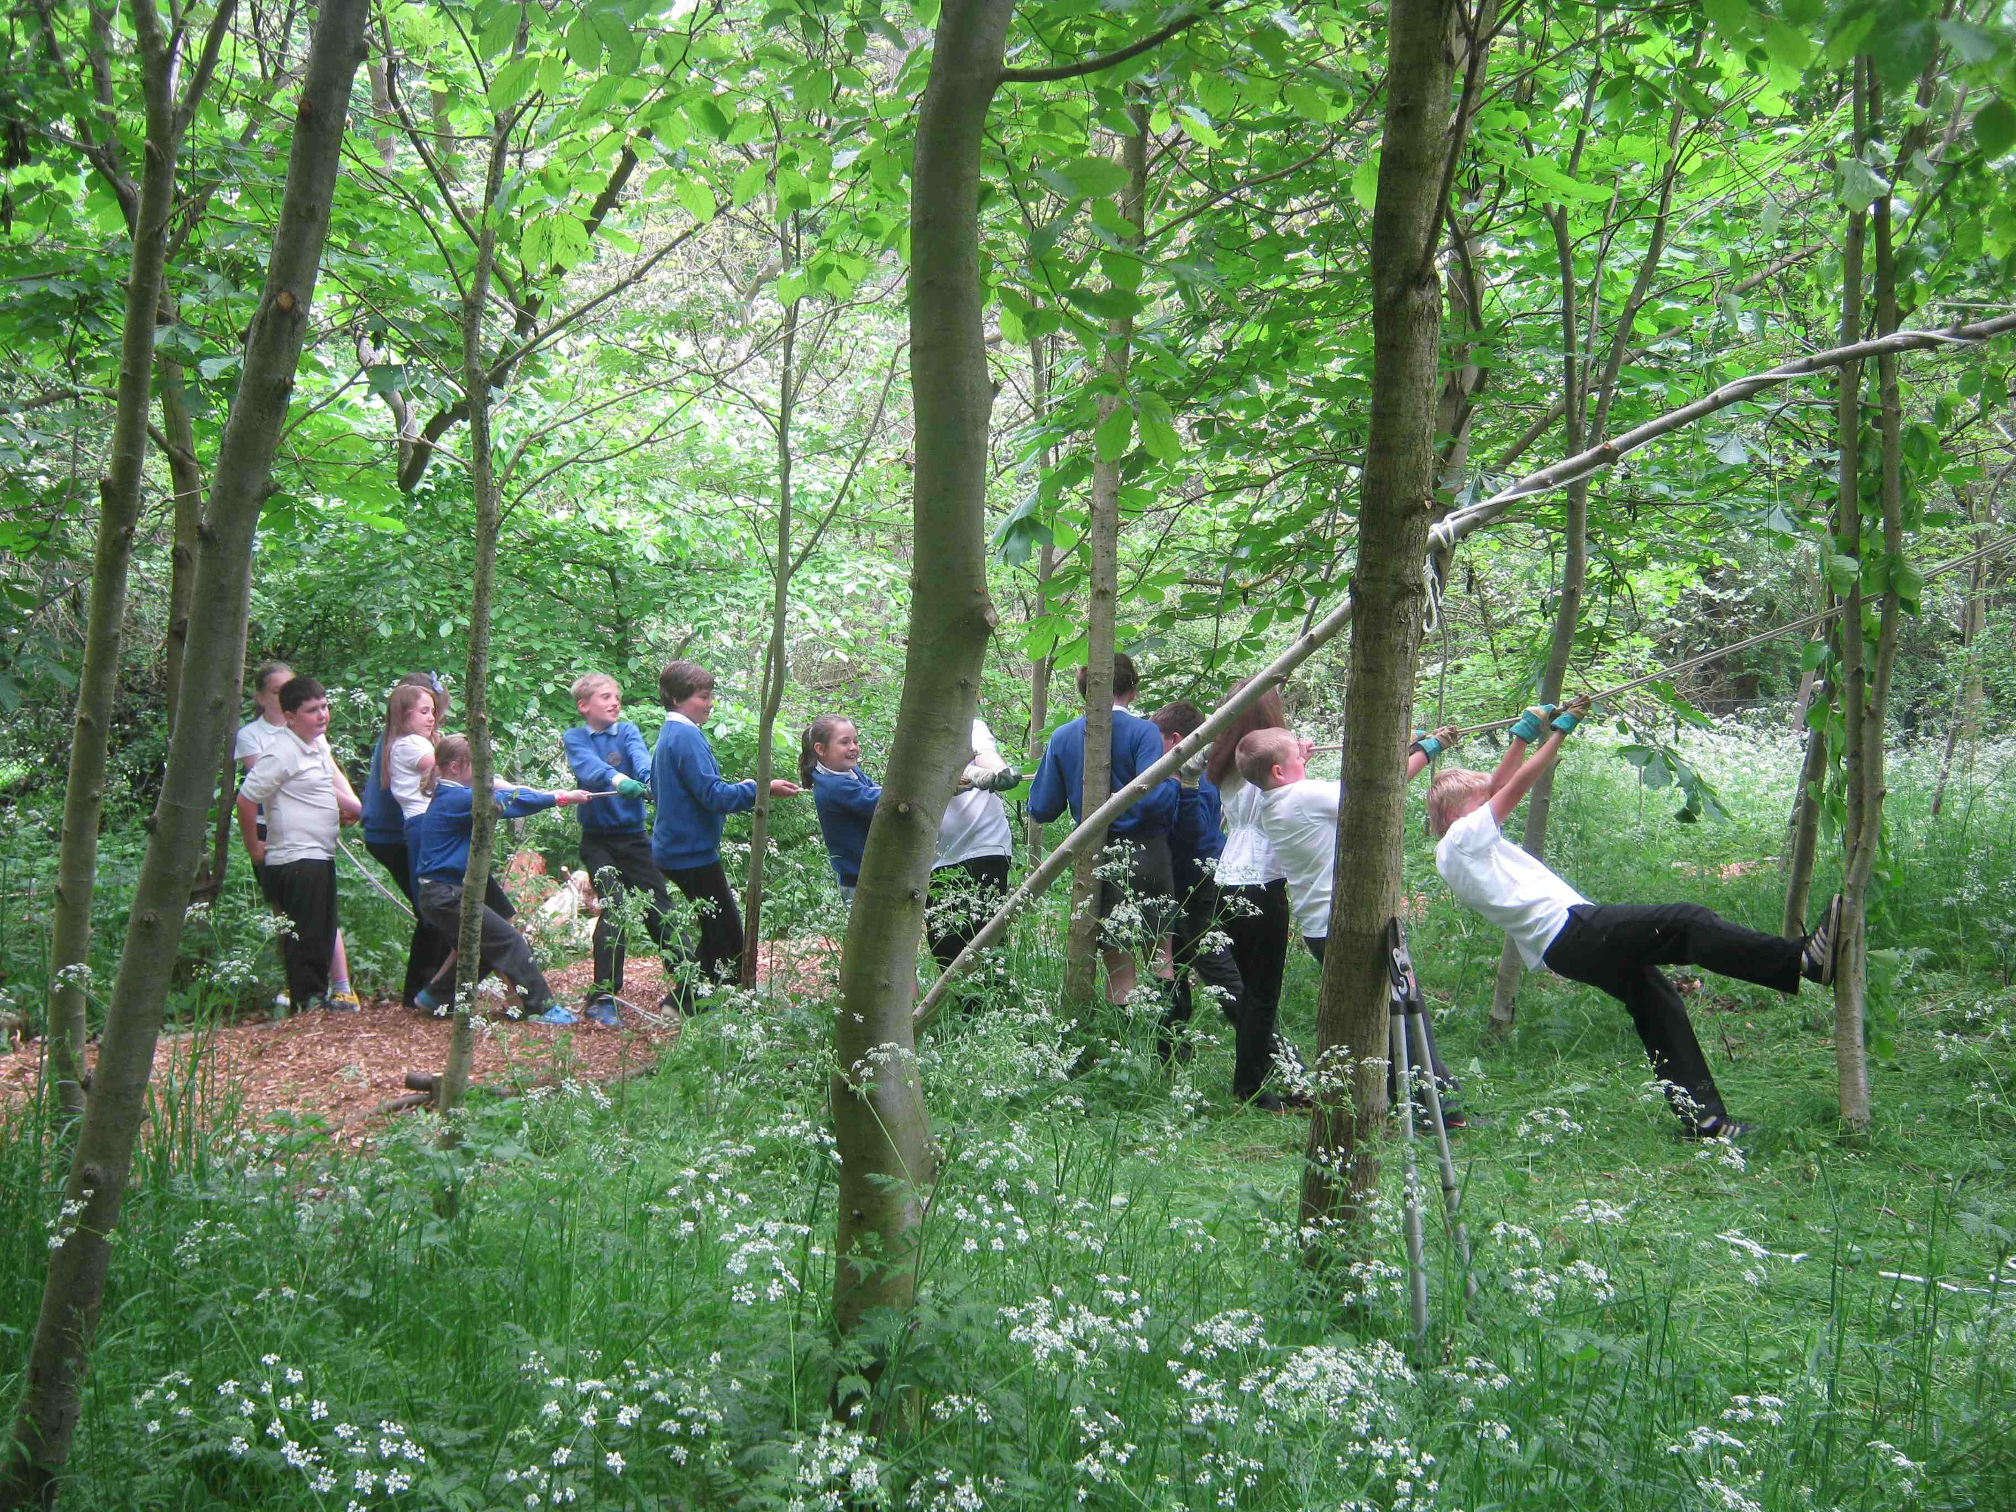
 | As well as maintaining the verges and public open spaces in the village, Durham County Council also provides active support in:  - Giving advice and guidance on suggested improvements and queries;  - Carrying out maintenance when requested e.g. weed killing, street sweeping, mending railings and repairing seats;  - Erecting the barrier baskets and agreeing to provide the plants;  - Supplying refuse bags and collecting them after a ‘Litter Pick’.  The council was hoping to organise a probation group to paint the seats and heritage board. Having waited for some time for this to happen, it was decided to paint them ourselves. |  |  |  |  |  |  |  |  |  |  |  |  | A1/A2/A4/A5  B2/B5  C1/C5
 | 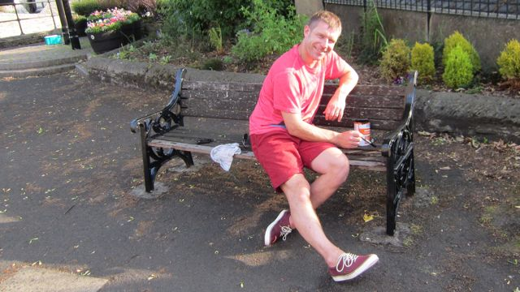 |  |  | 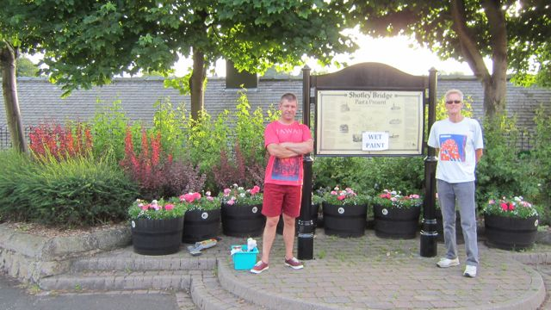 |  |  |  |  |  |  | 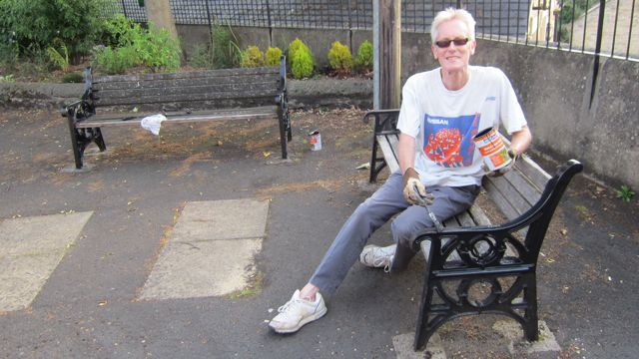
 | At the last Village Trust open meeting it was agreed to move the recycling bins, as these have long been considered unsightly and unsuitably placed in the centre of the village. It is not only the bins themselves, but also the plastic bags left in between the bins, broken glass and extra bottles left when the bins are full. Recently the situation has worsened, with the dumping of tyres and TVs, following the closure of the local council tip. Every residential property in County Durham is provided with recycling bins and bottle boxes, which are emptied every two weeks.
 | 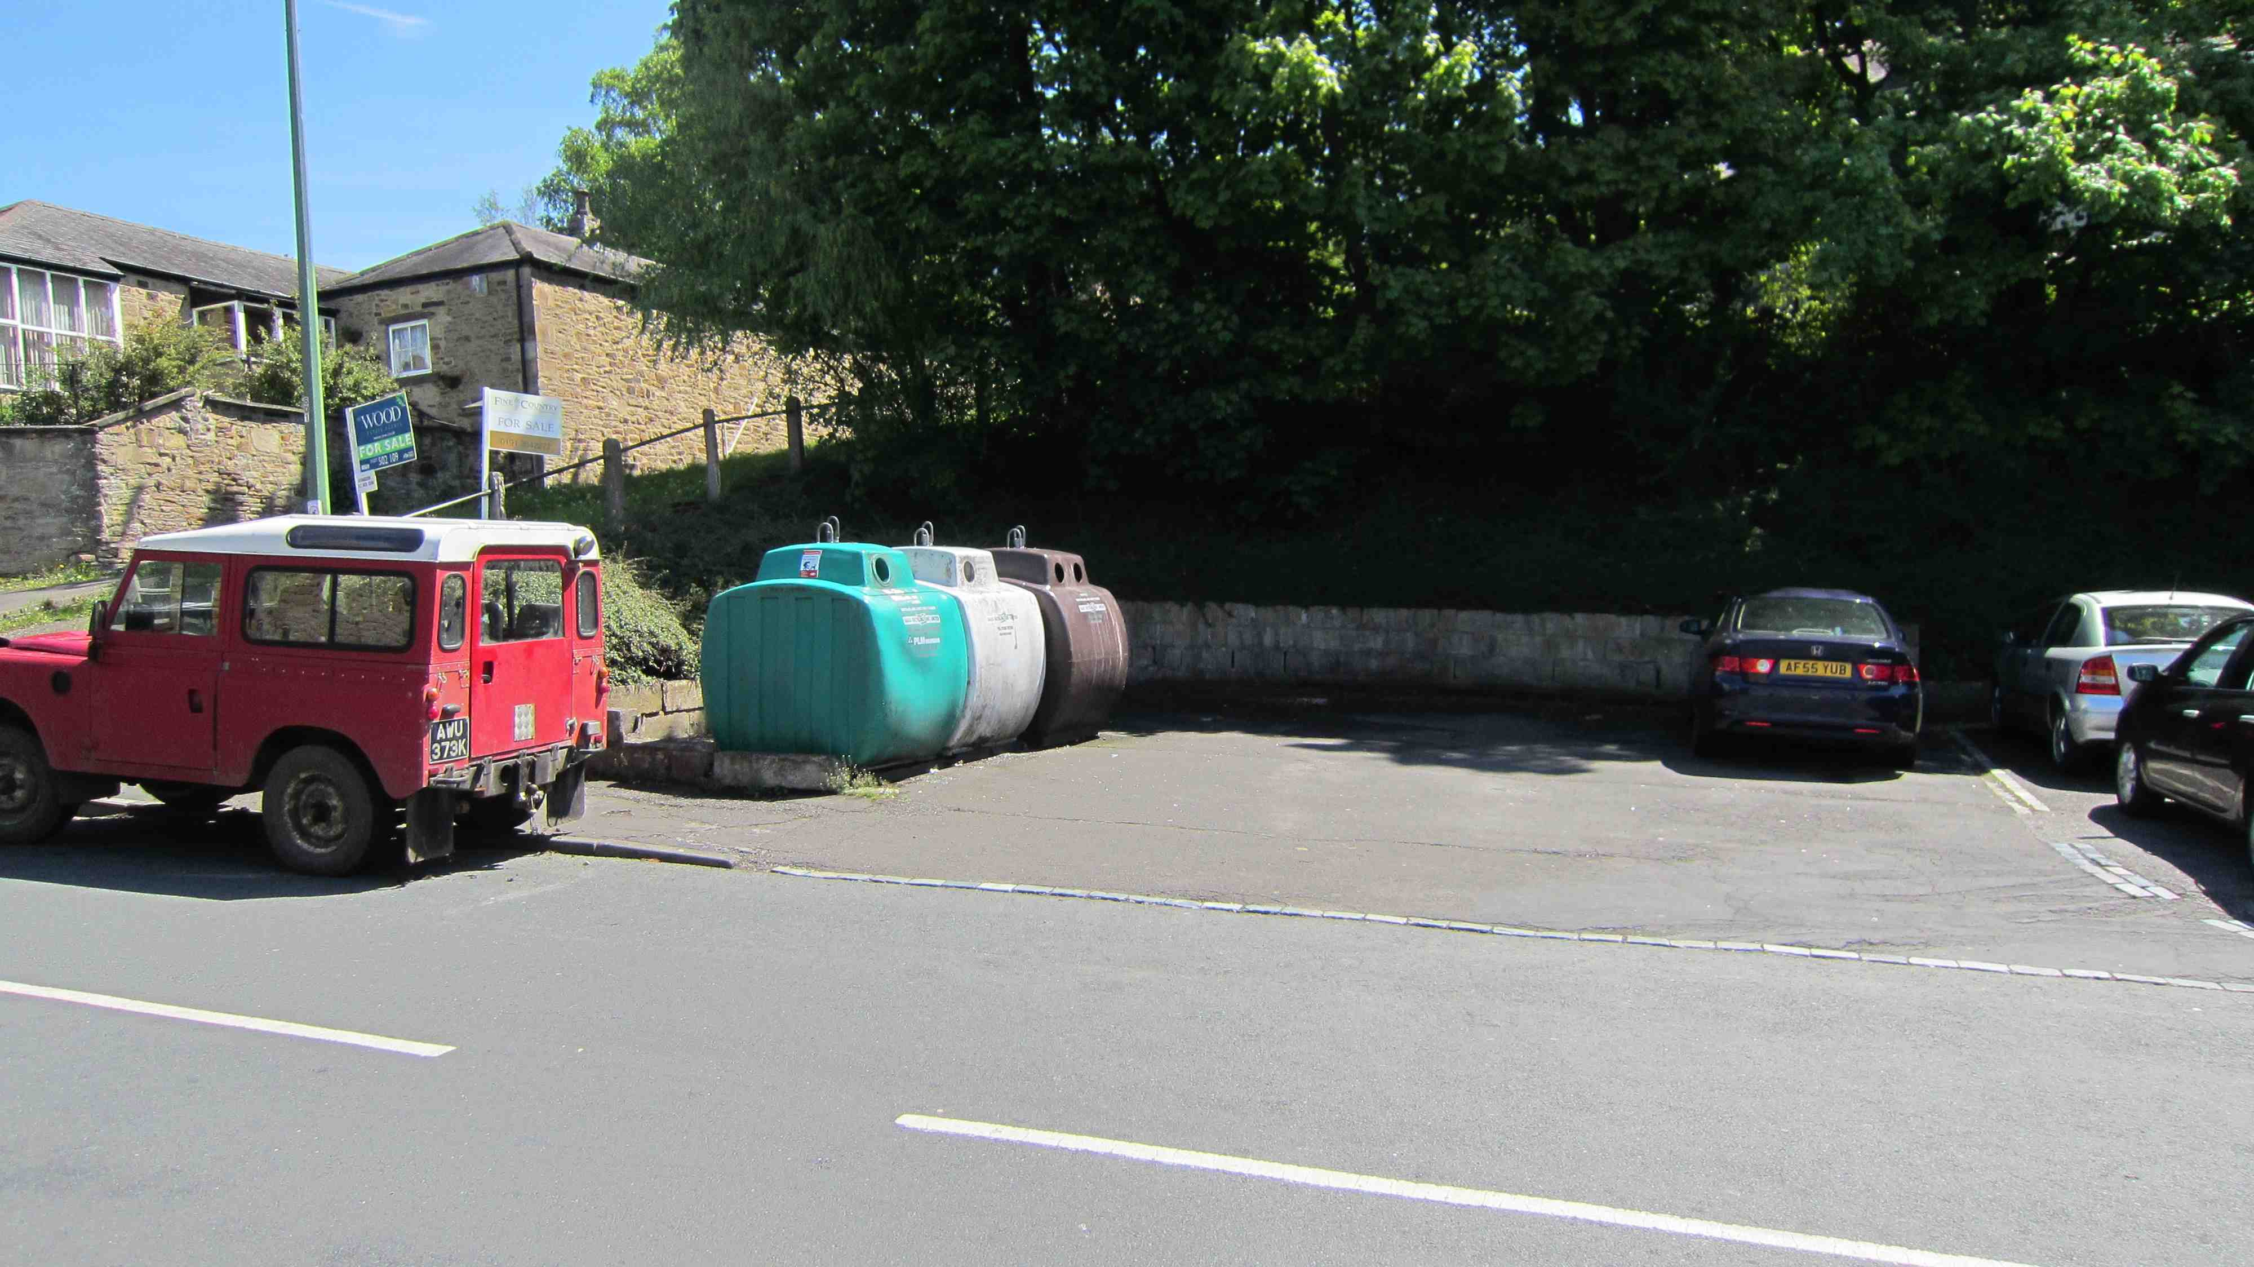
 | Members of the Village Trust have been given a leaflet about ‘How to create a wildlife habitat in your garden’, which was produced by one of the volunteers.  The field opposite the Catholic Church on Snows Green Road has the potential to become a wildflower meadow. With the woodland immediately behind, it is an important wildlife habitat for deer, badgers and foxes. The horses that grazed the field last year have been taken off and the Trust is hoping that the owner will allow us to help manage the site to improve its biodiversity. Specialist advice has been obtained as to how best to do this, but this would inevitably be a long-term project. If the wildflower meadow were to be restored, it is hoped that we can organise educational visits for the local community and school children. |  |  |  |  |  |  |  |  |  |  |  |  | B1  C1
 | 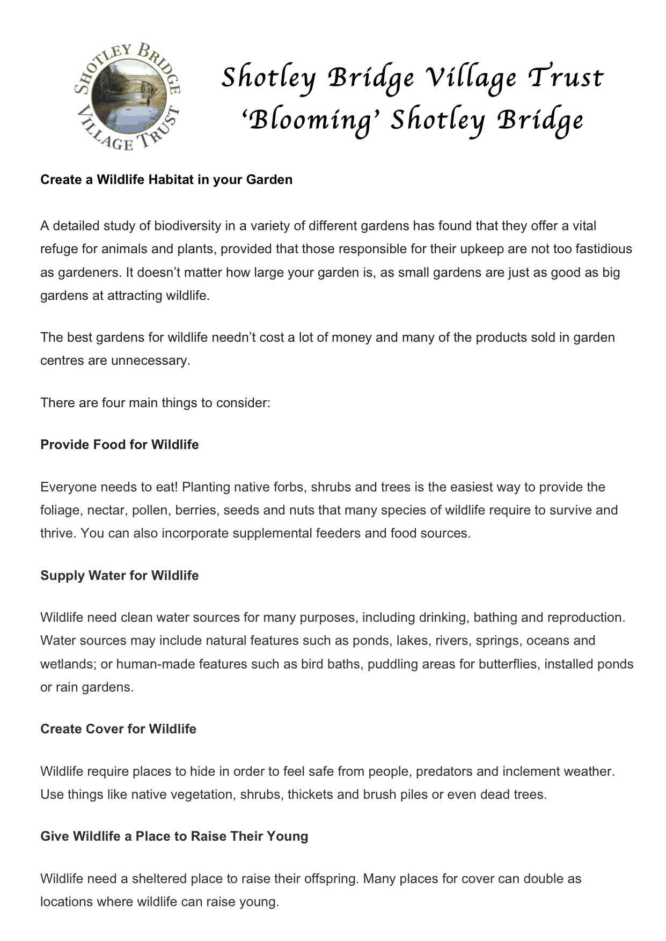 |  |  |  |  |  |  | 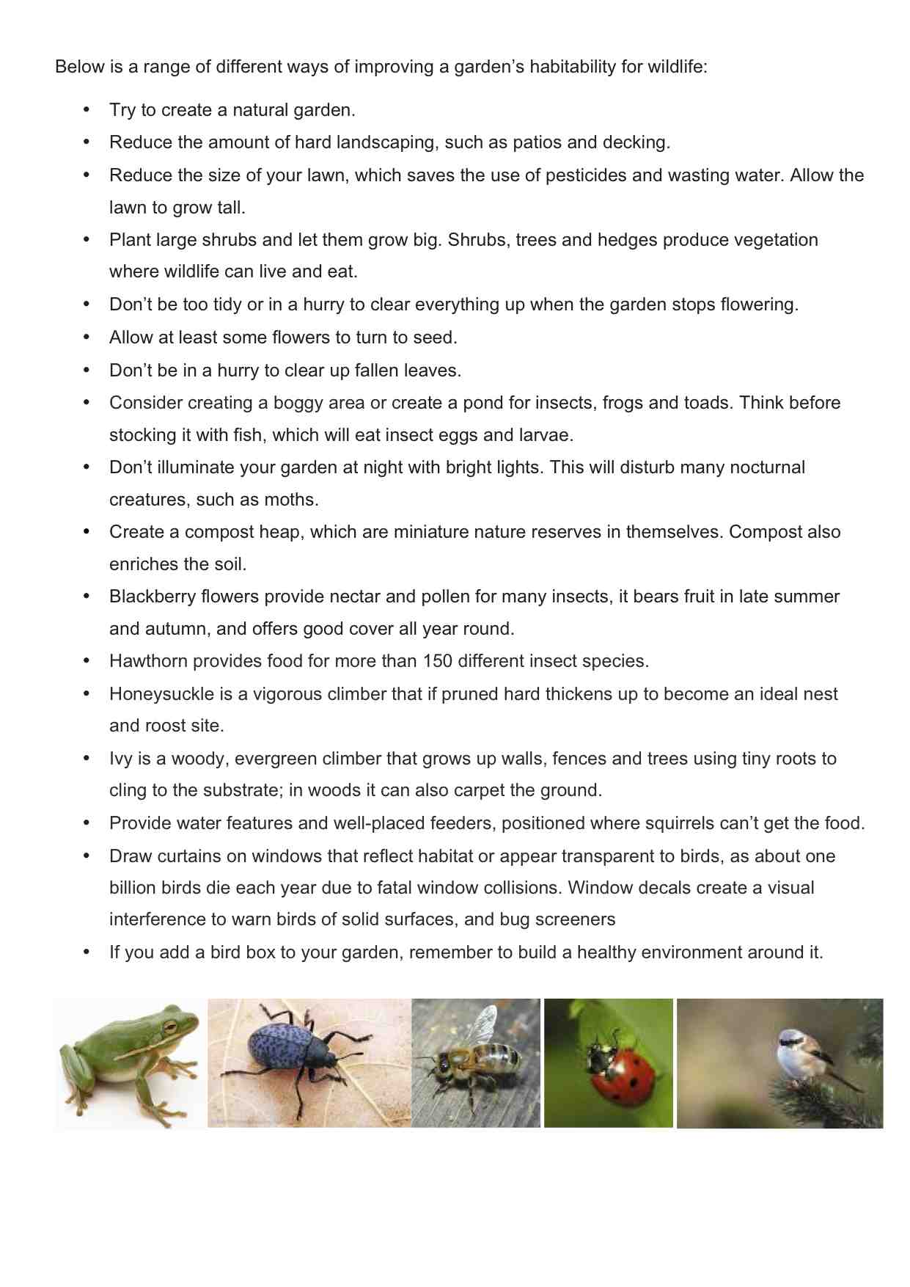
 | 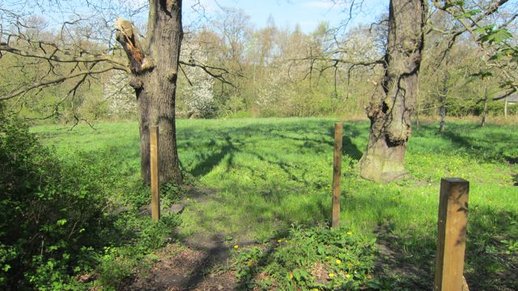 |  |  |  |  |  |  | 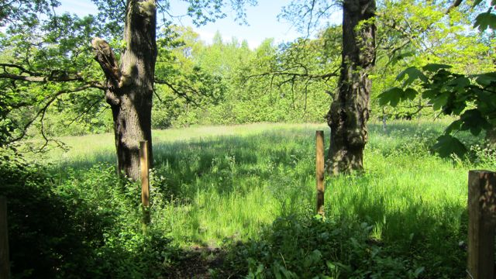
 | Heritage plaques have been funded by the Village Trust and erected at historical sites or properties of interest. The Trust intends to provide more of these in future, as opportunities and funding allow. This year, volunteers have re-painted the historic road sign at the junction of Benfieldside Road and Snows Green Road and the heritage board in the ‘Triangle’.  In 2014 the country will be commemorating the centenary of the start of World War I. We have already started planning for this by carrying out preliminary research into the impact of the war on residents of the village. We have also researched different poppy seeds and the most appropriate time for planting them.  Photographs have been taken of the village this year from the same vantage points as used in the past, enabling local people to compare the same view but at different times in our history. This ‘Then and Now’ photographic display has been shown at a number of venues and events (Blackhill & Consett Heritage Centre Initiative; Village Trust AGM/open meeting; Area Action Partnership Forum Event). These photos are also available for a wider audience on the Village Trust blogsite in the ‘old photo gallery’.  At the Village Trust AGM/open meeting we celebrated its 25th anniversary this year with a cake. There was also a display outlining what the Trust has been involved with during this time, including publications about its history and village life. These are also going to be published on the blogsite. |  |  |  |  |  |  |  |  |  |  |  |  | B3  C1
 | 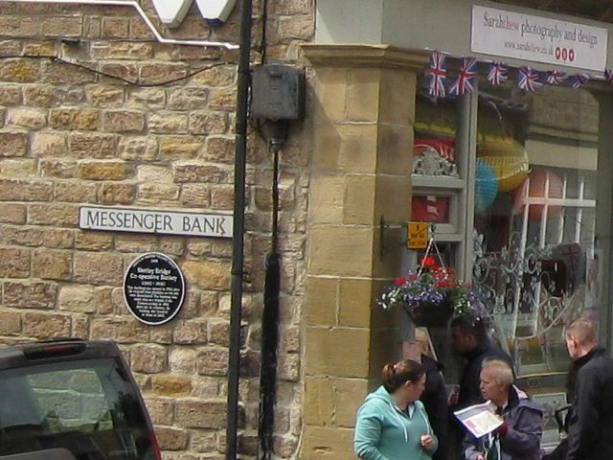 |  | 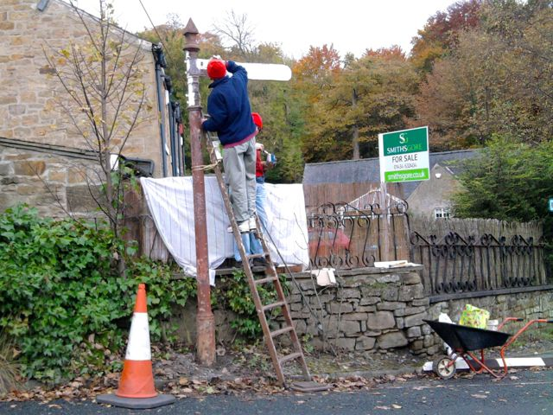 |  |  |  |  |  |  |  |  |  | 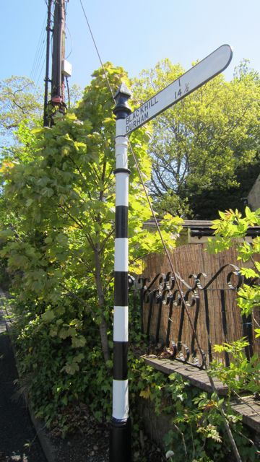
 | 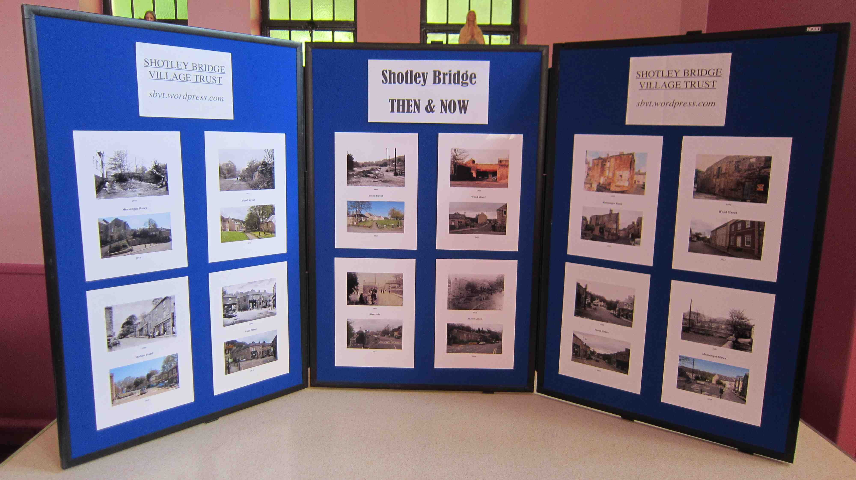 |  |  |  |  | 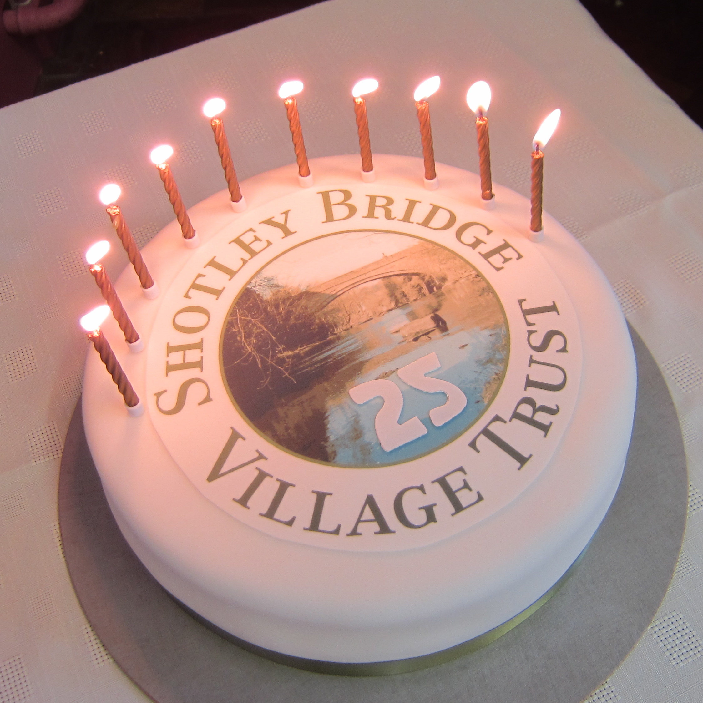 |  |  |  | 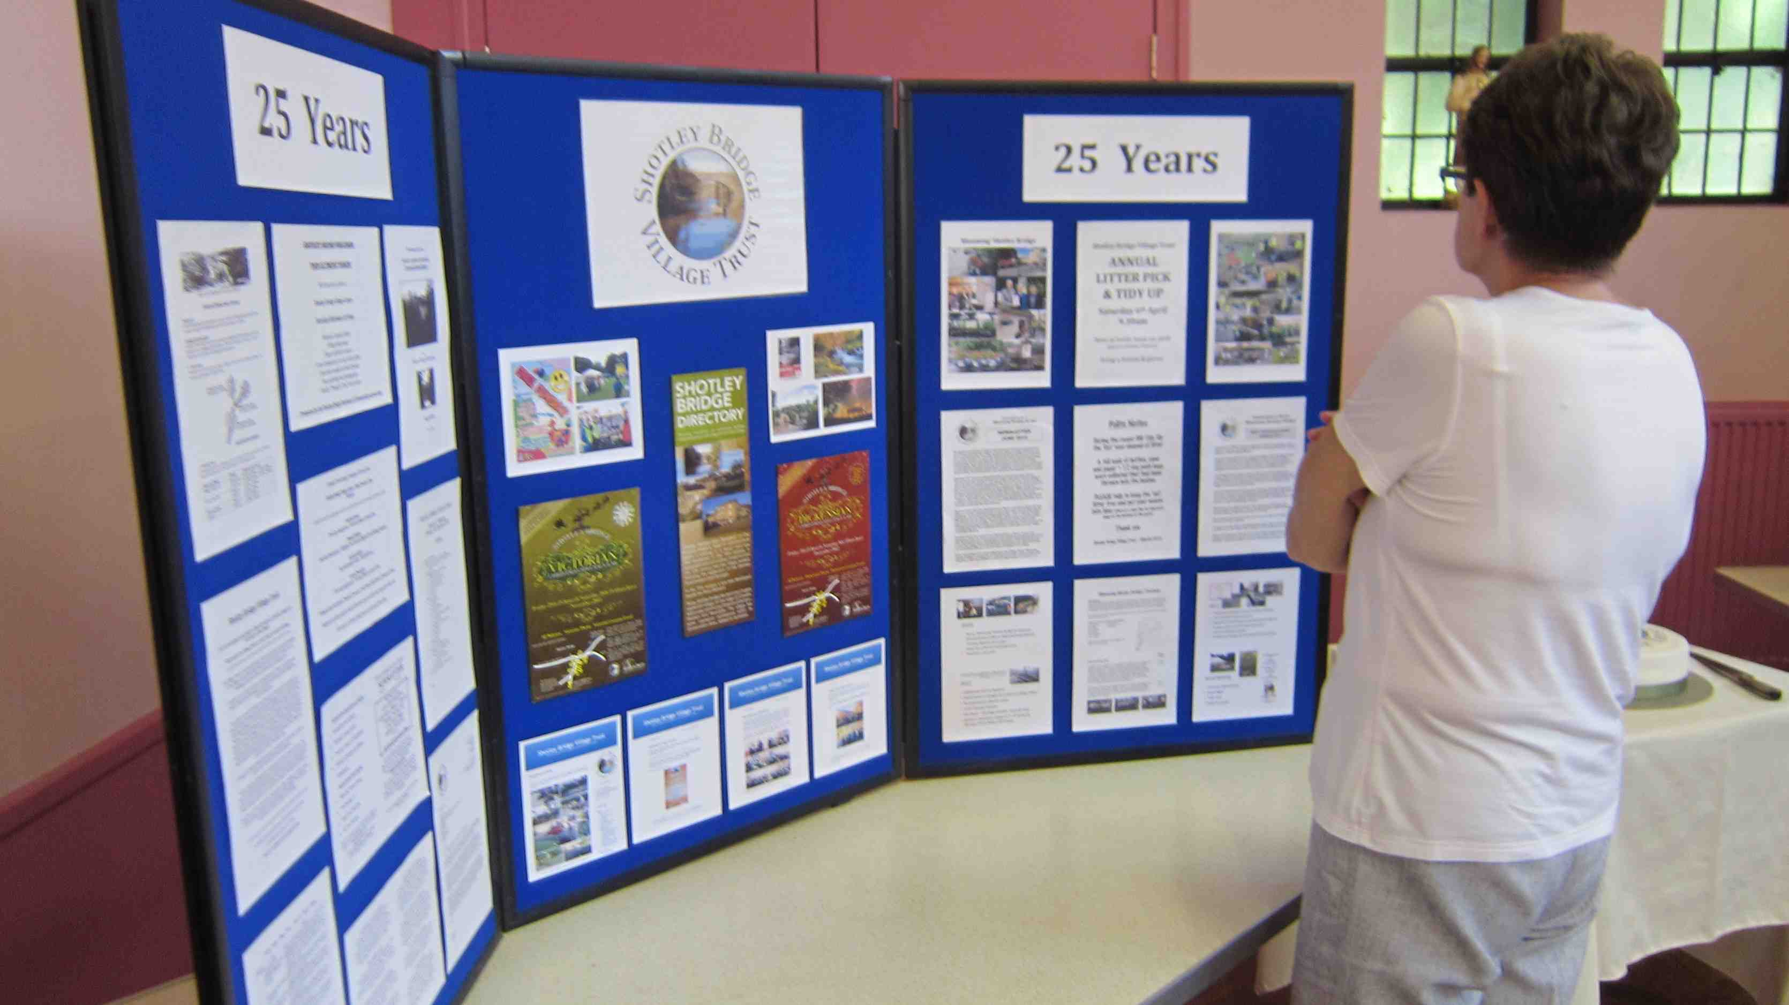
 | Lydia Price who produces Treasure Trails for towns and villages in County Durham and lives in Shotley Bridge, devised and published one for the village at our request. Members of the committee worked with Lydia to outline places of historical interest along the route. The Village Trust has sponsored its publication, with the Trust being publicised on the back page. These trails are now available on the Treasure Trails website as well as being mentioned on the Village Trust blog site. It is hoped that some of the local businesses will sell the trails. Lydia offered to work with the Junior School where the children could be involved in producing their own trail. |  |  |  |  |  |  |  |  |  |  |  |  | B3  C2  C5
 | 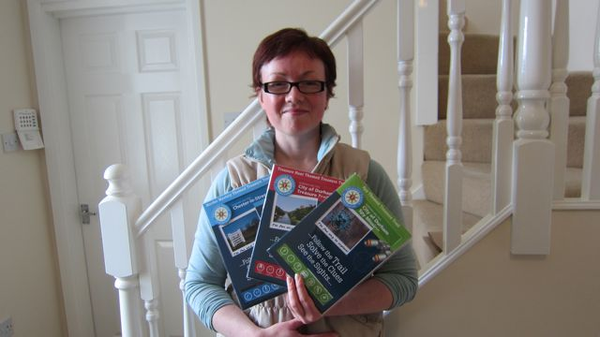 |  | 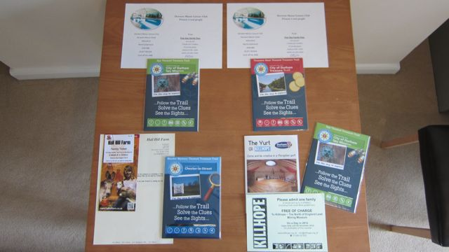 |  |  |  |  |  |  |  |  | 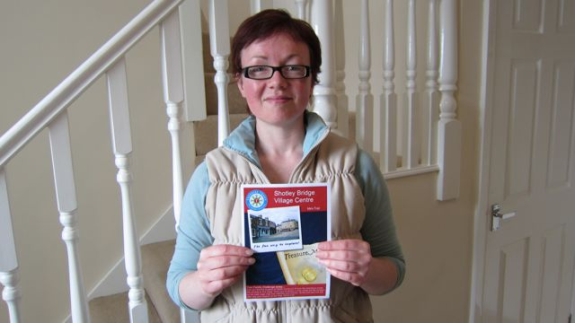
 | Many years ago the Village Trust produced a Heritage Trail of the village, which outlined specific places of interest en route. This is in the process of being re-written by two members of the Village Trust committee and is to be published again. There is currently a draft on the ‘Shotley Bridge – The Village’ Facebook site. |  |  |  |  |  |  |  |  |  |  |  |  | B3
 | The Village Trust blogsite (sbvt.wordpress.com) is run by one of our volunteers and is continually updated. It contains information and photographs about the history of the village, what has happened in recent years and plans for the future. |  |  |  |  |  |  |  |  |  |  |  |  | B3  C2
 | For the last 2 years we have organised a ‘Best Front Garden Award’, which has been very successful. This year we are giving a ‘Best Hanging Basket Award’, with a certificate and Beveridges’ Nursery voucher for the winners. Residents within the ‘In Bloom’ area receive a leaflet updating them about the Trust’s entry in Northumbria in Bloom, thanking them for their continued efforts and encouraging them to take part in the hanging basket competition. Dog fouling is an issue that has also been highlighted.  Each year the majority of the businesses in the village put up hanging baskets, which enhances the overall look of the village. This year it was decided to have a ‘Best Hanging Basket Award’ for businesses, too. A flyer was distributed to all the businesses explaining what was involved. |  |  |  |  |  |  |  |  |  |  |  |  | A1/A3/A4  B4  C1/C2/C3
A record of tasks and events that have taken place over the past year is detailed in the ‘Blooming Shotley Bridge’ diary. |  |  |  |  |  |  |  |  |  |  |  |  |  | C4
 |  | 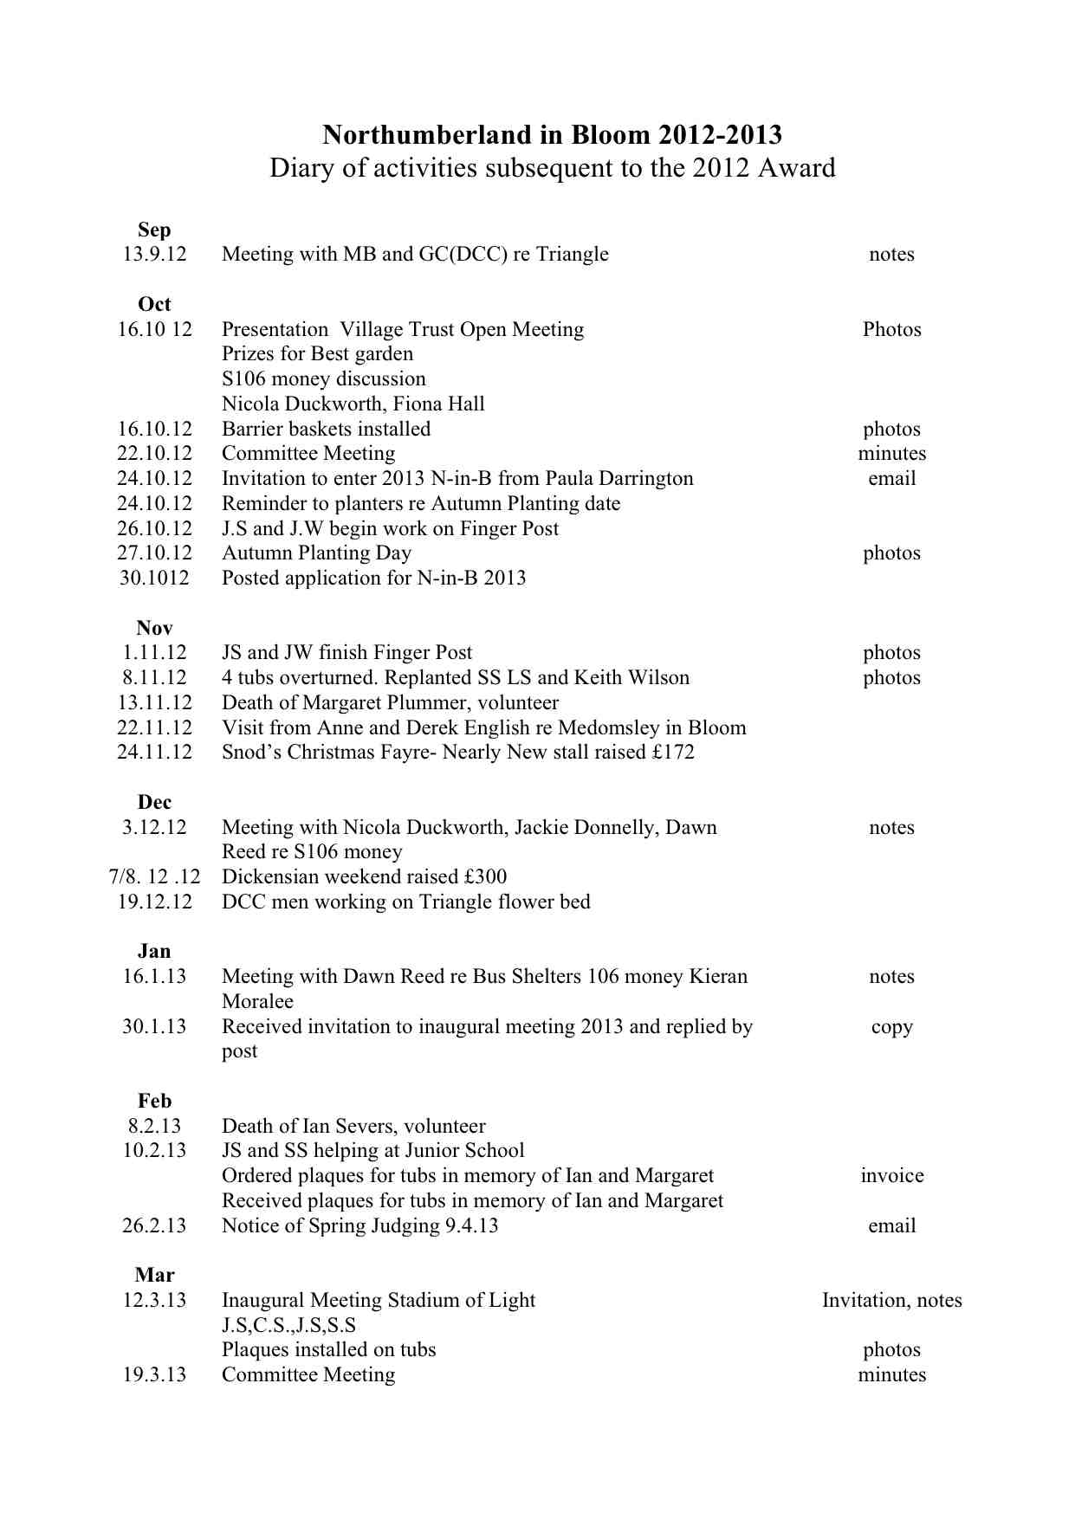
 |  | 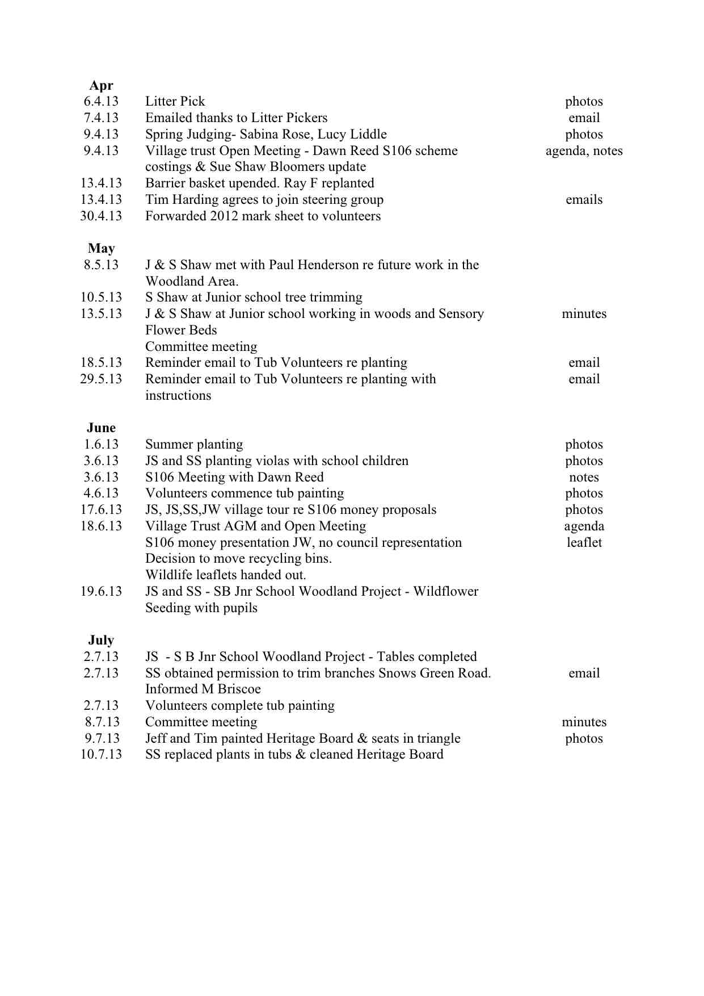

Future Plans include:  a) Partnership and community participation plans  - Approach the Methodist Church to ask if sustainable plants could be put in the front border.  - Continue close links with the school by developing further activities/projects.  - Encourage the local nursery school and Golden Flower takeaway to put hanging baskets outside their premises.  - Further develop our links with other community groups.  b) Education Aims  - Continue to display notices informing the residents and visitors about litter picking dates, social events, ‘Northumbria in Bloom’ judging dates etc.  - Work with the local schools about recycling, litter prevention, sustainability, wild flowers and wildlife.  - Organise more outside speakers for Village Trust Open Meetings similar to the one about the Tyne Rivers Trust.  - Display notices informing locals and visitors about the work carried out by Village Trust volunteers.  - Continue to update the SBVT blogsite and ‘Shotley Bridge – the Village’ and ‘Blooming Shotley Bridge’ Facebook sites.  c) Preparation for future development  - Attend future consultation meetings organised by Durham County Council about the spending of the S106 money.  - Continue looking at the possibility of incorporating a replica of the drinking pant, with the inclusion of an outside water tap.  - Plant the sustainable bed in the autumn, as previously mentioned.  - Commission the design of a feature commemorating the history of the village e.g. German sword makers, papermaking, the Spa etc.  - Plant poppy seeds and plan a red colour scheme for 2014.  - Replant daffodil bulbs from the tubs in the roadside verges.  - Investigate the possibility of a ‘Heritage Walks’ information board in the village.  - Design features for the signed entrances to the village perhaps incorporating ‘Litter Free Village’.  - Re-plant the rose bed with shrubs at the bottom of Benfieldside Road.  - Increase the number of seats in the village.  - Tidy-up the millrace.  - Extend the present ‘In Bloom’ boundary up to the village entry signs. | A1/A2/A3/  B1/B2/B3/B4/B5  C1/C2/C3/C4

Funding |  |  |  | C4
Grants from the Derwent Valley Partnership (£2000) and a local councillor’s Initiative Fund (£2000) were used to purchase 50 tubs, the barrier baskets, a water trough and new shrub planting in the ‘triangle’. The BBB&SB Partnership gave us £375 for planting to celebrate the Olympic Torch and Queen’s Golden Jubilee last year. |  |  |  | C5
A £100 donation was received from the Snods’ Quest Club. |  |  |  | C5
Every year the Business & Community Partnership, which includes the Village Trust, organise a Christmas Spectacular, including a fashion show in the clothes shop ‘Eve’. 25% of the money raised is for the ‘Blooming Shotley Bridge’ fund while the remaining is for Willow Burn Hospice. Over £300 annually has been raised in the past 3 years. |  |  |  | C3C5
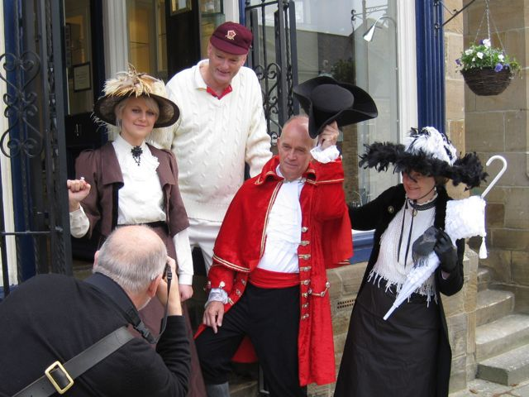 | 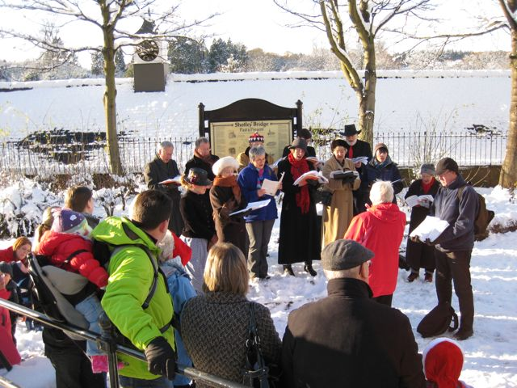 |  | 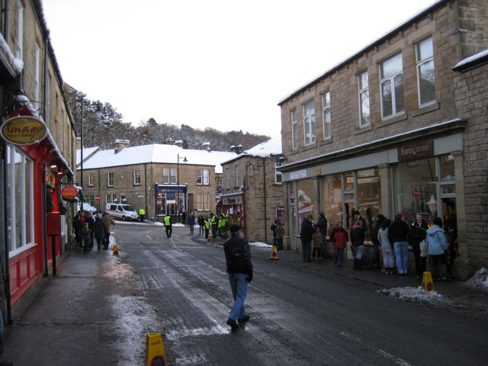
For the last few years there has been a local community event at the Spa Grounds in Shotley Bridge. In 2011 we had a plant stall, which raised £88, whilst in 2012 a tombola made £60. In November 2012 a ‘Good as New’ stall at The Snods church hall Christmas Fayre raised £172. We intend having the same stalls again this year to raise funds and awareness of the initiative. |  |  |  | C3/C5
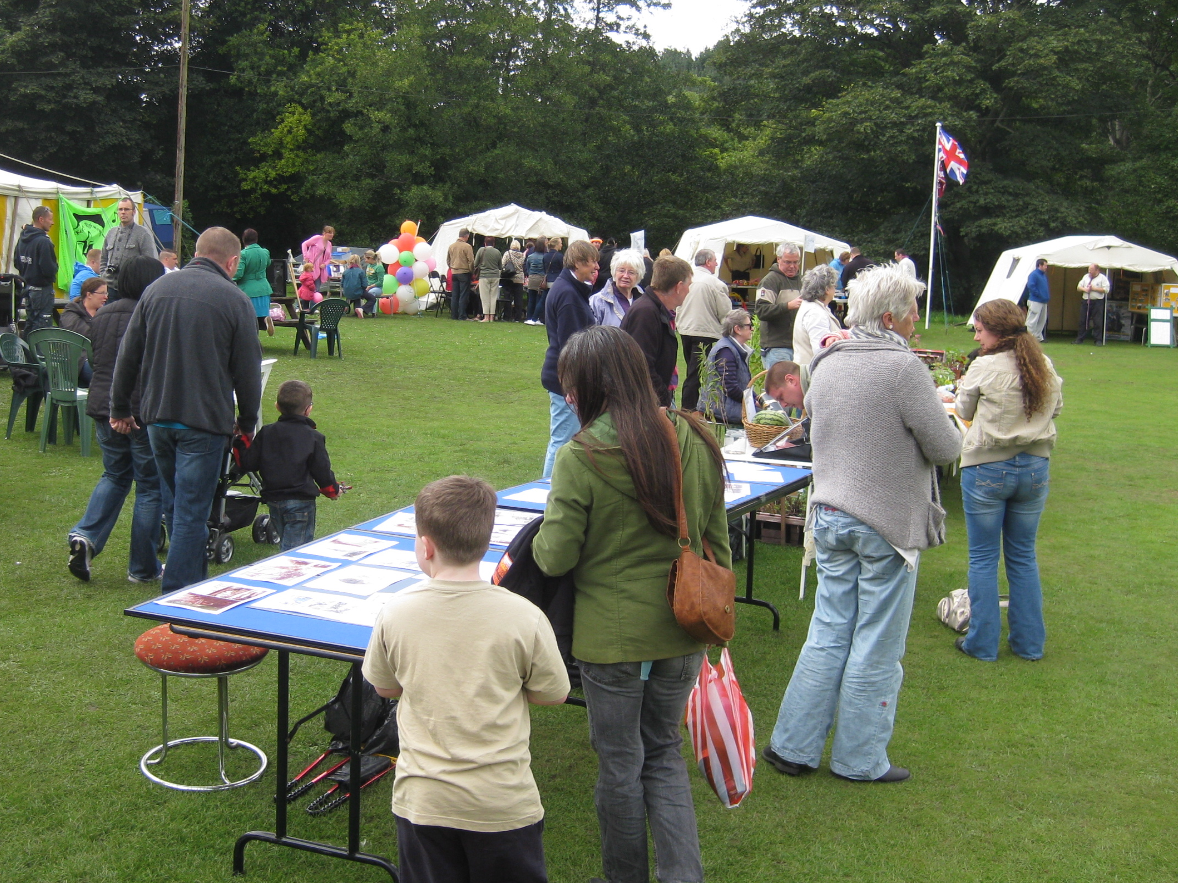 | 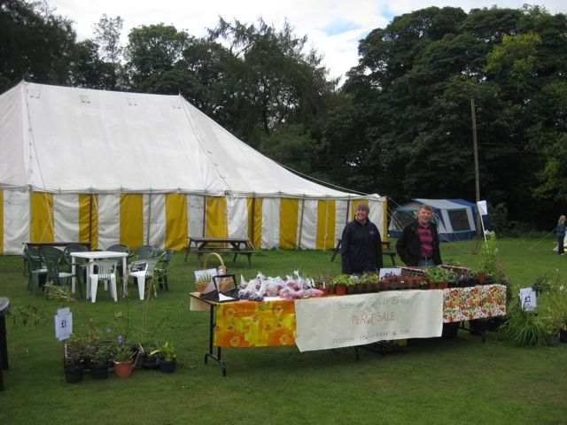 |  | 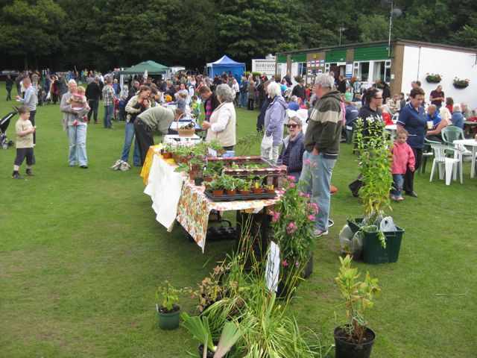
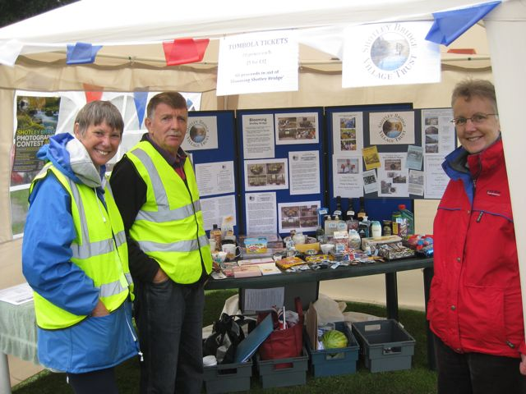 |  | 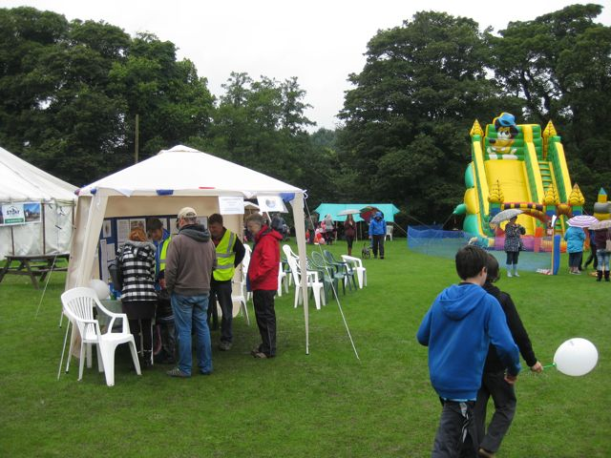
Also 2 social events have previously been organised which raised over £1000. Other events will need to be arranged, as funds are required. |  |  |  | C3/C5
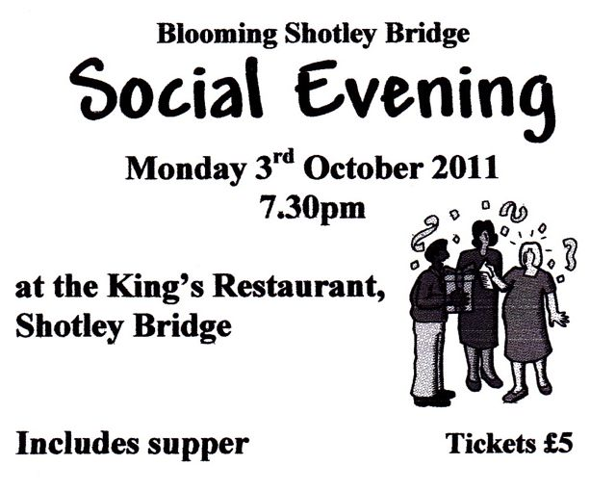 |  | 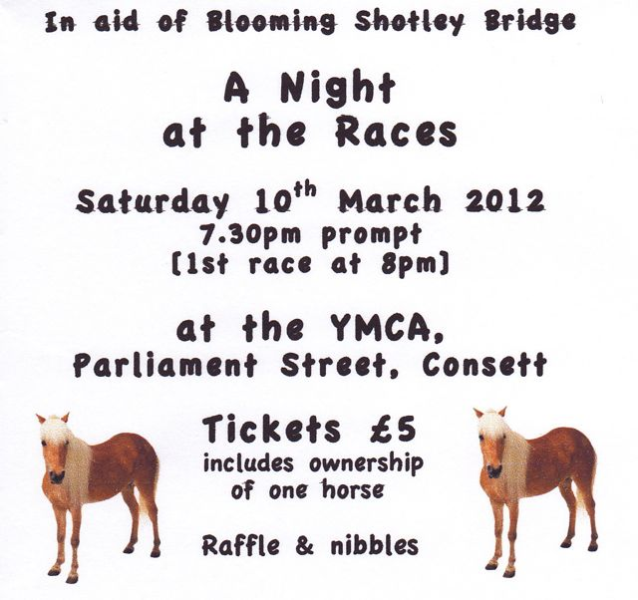

Press and Publicity
The ‘Northumbria in Bloom’ poster is displayed on the village notice board, in local businesses and at community locations. |  |  |  |  |  |  | C2
Information about ‘Blooming Shotley Bridge’ has been on the Derwent Valley Life website and in the Derwent Valley News.
Posters for events are displayed in businesses throughout the local area.
The Village Trust notice board in the centre of the village is updated on a regular basis with information about ‘Blooming Shotley Bridge’ and other community activities.
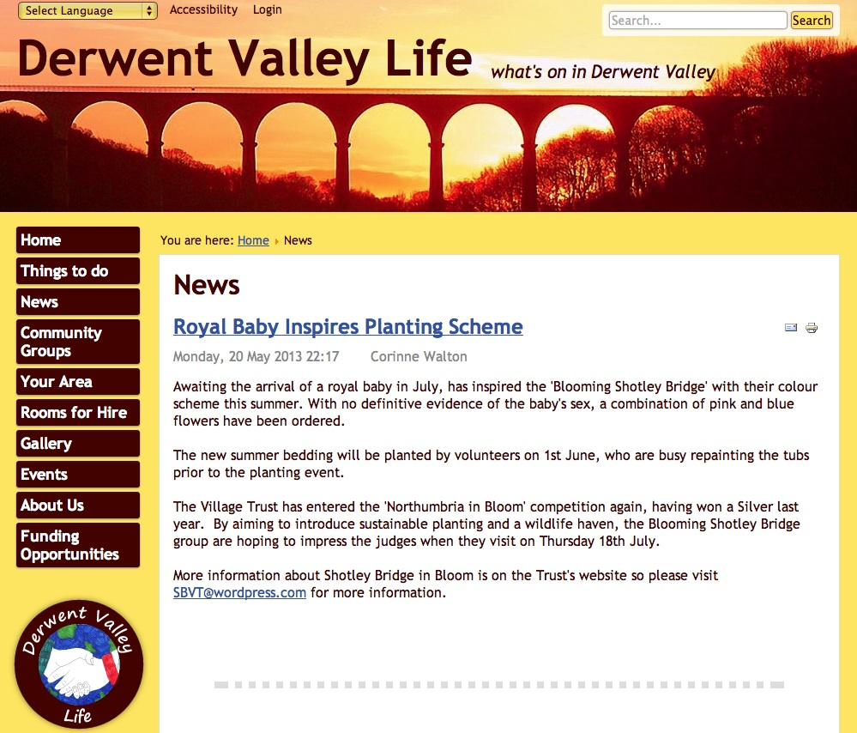 |  |  | 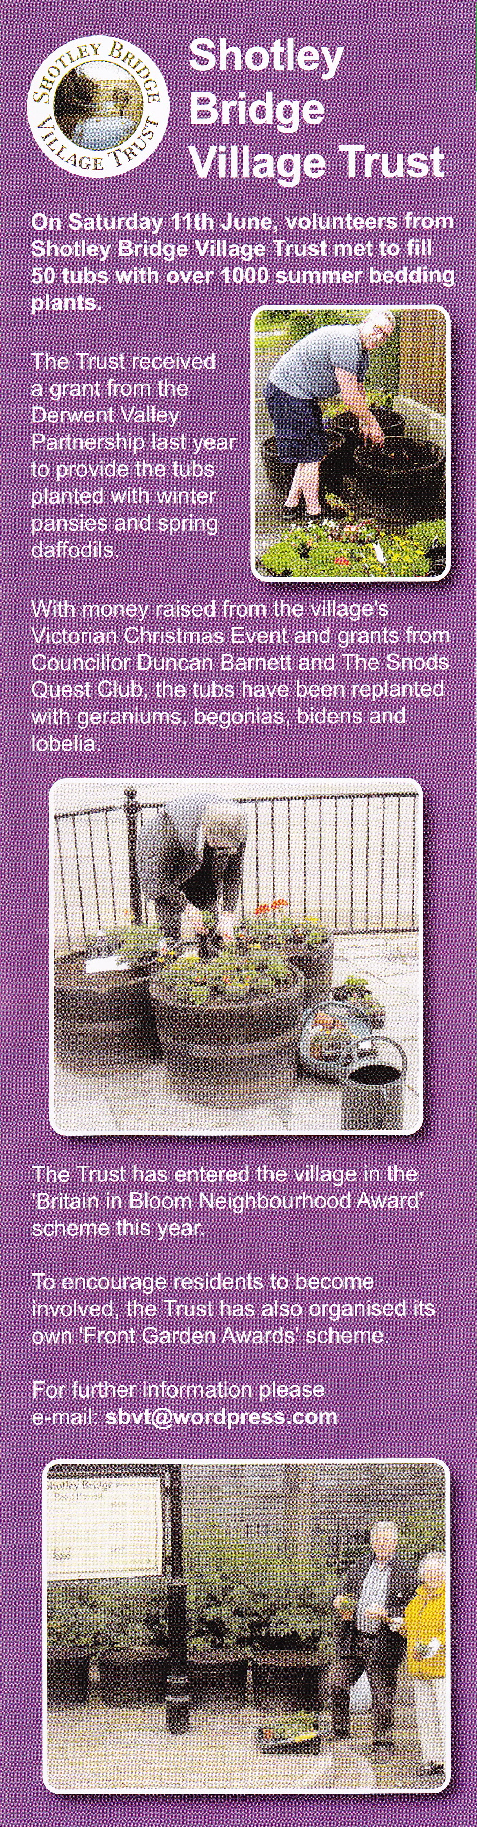 |  | 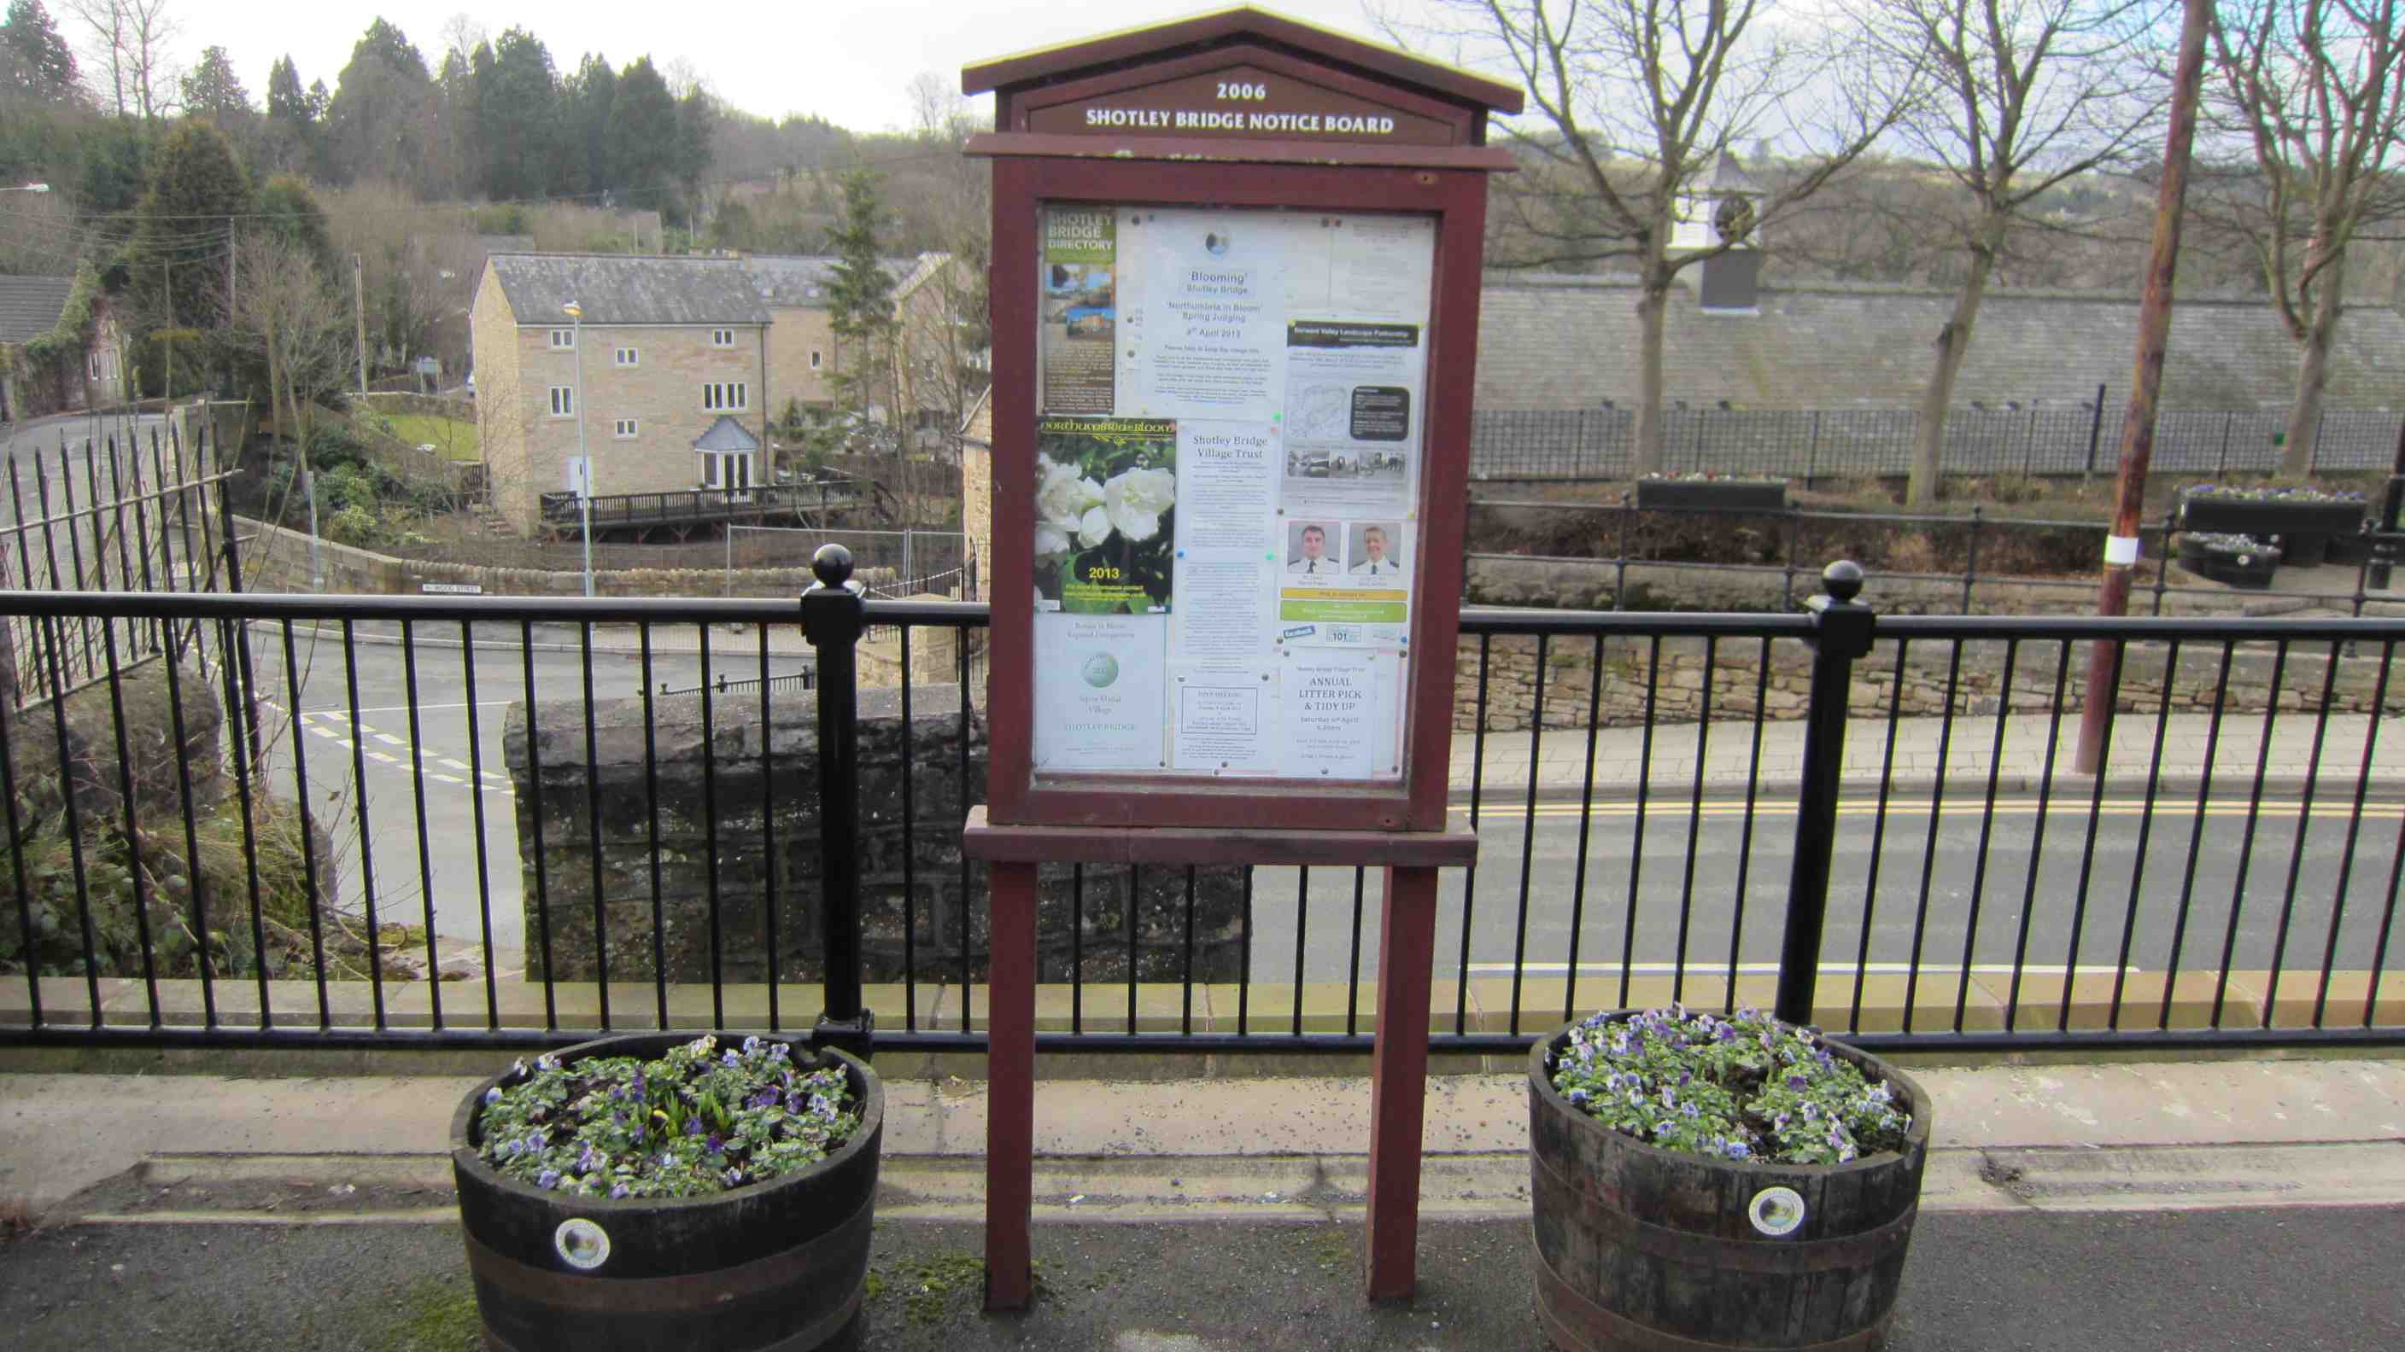
Village Trust newsletters are distributed to members prior to an open meeting (3 times a year) - an example is shown below. |  |  |  |  |  |  | C2
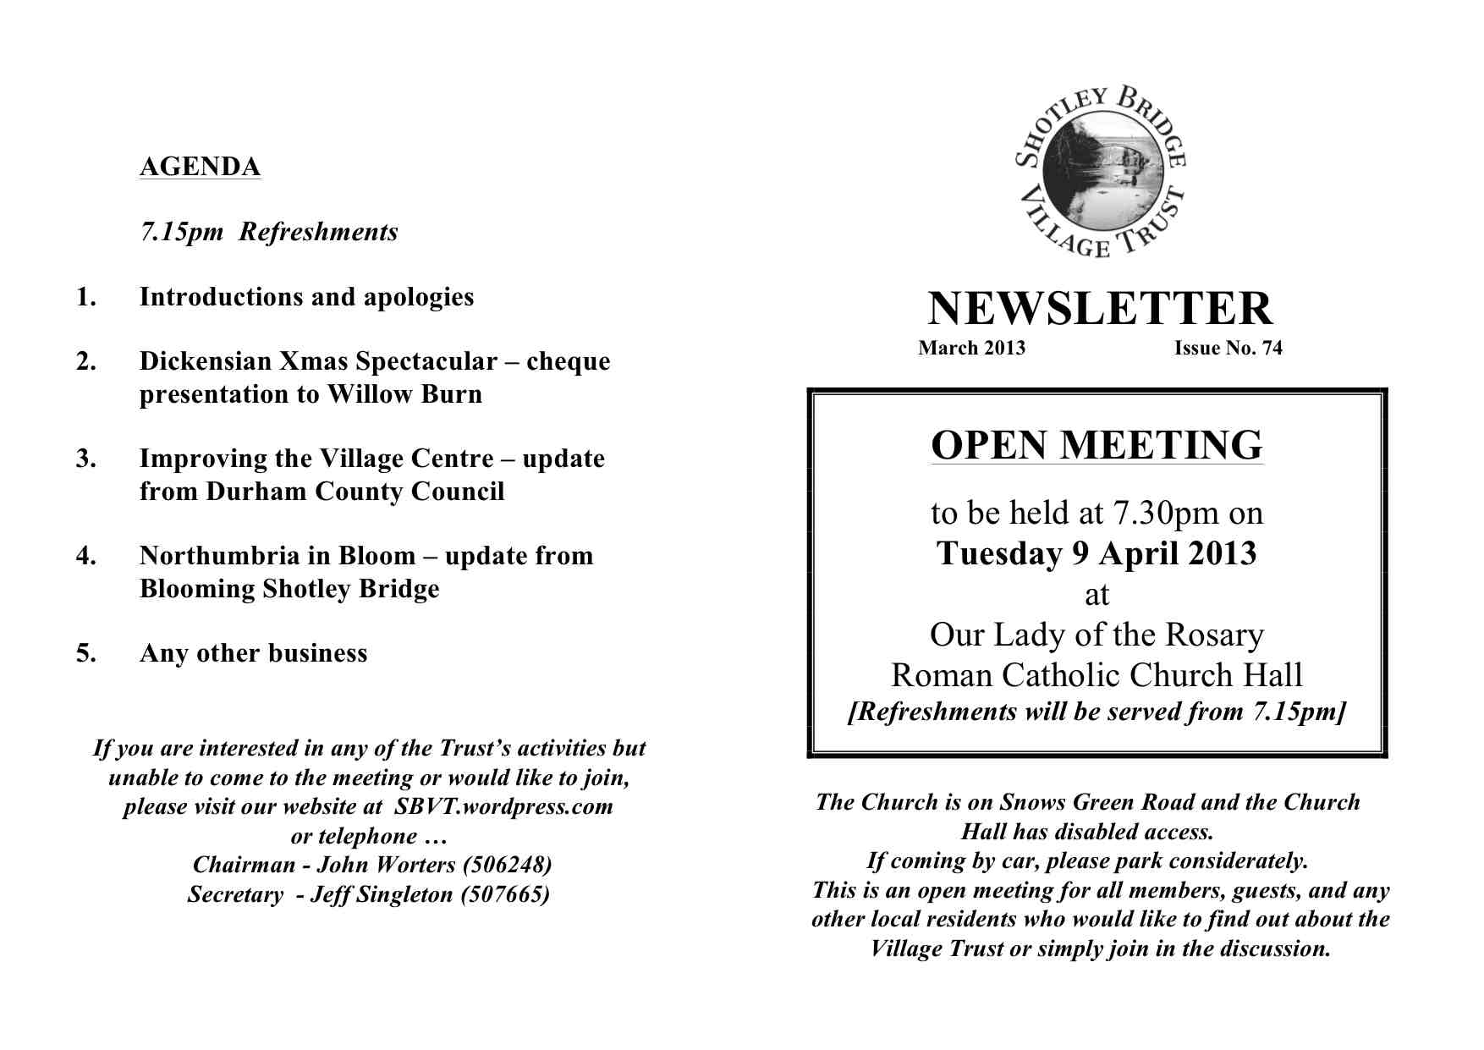 |  |  |  | 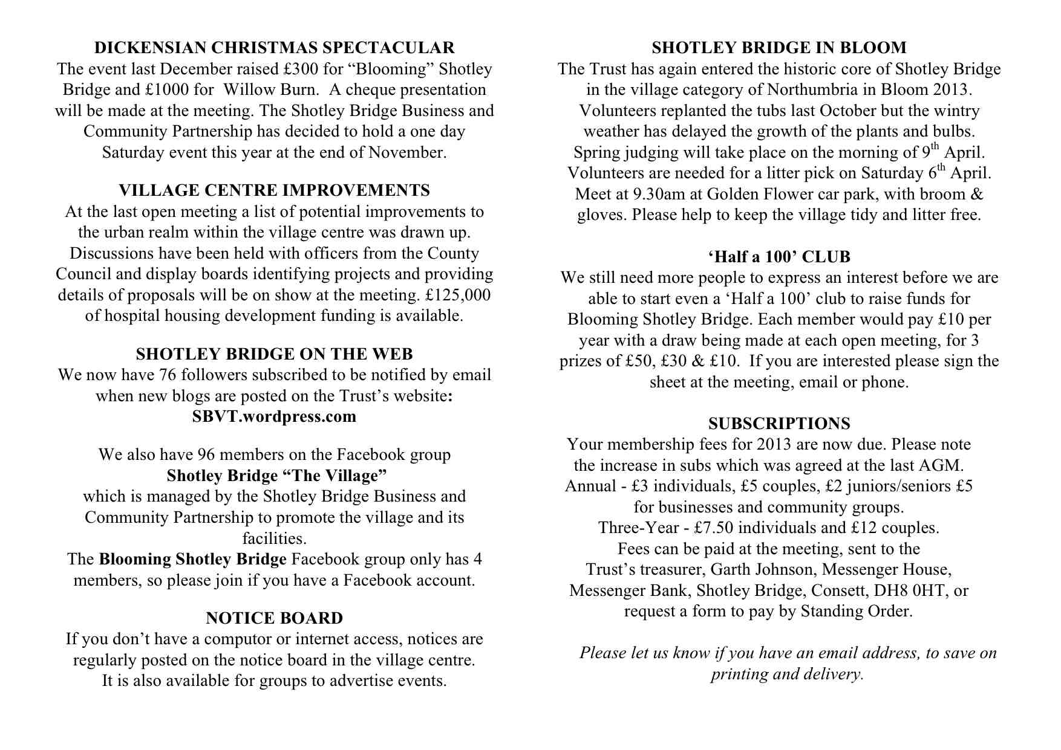
‘Blooming Shotley Bridge’ reports are given at Village Trust Open Meetings, which update members on progress so far, achievements, future plans, fund-raising events etc. See example of a presentation below. |  |  |  |  |  |  | C2
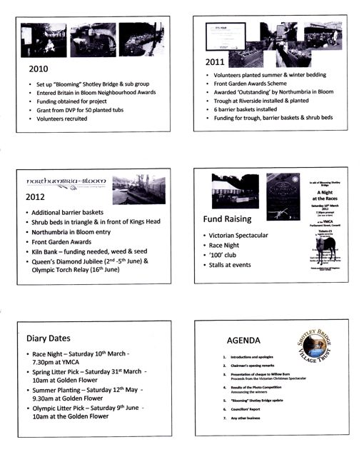
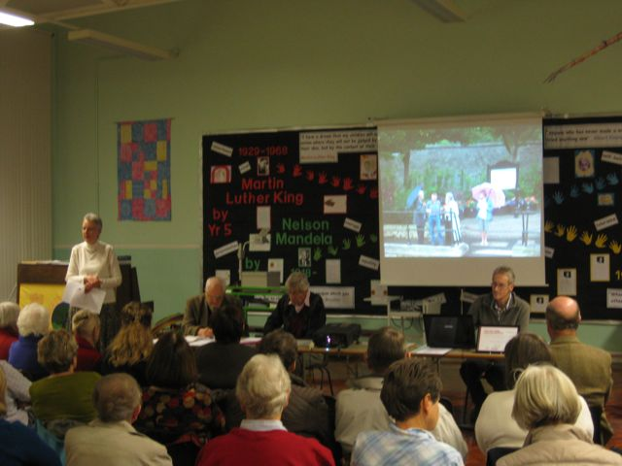 | 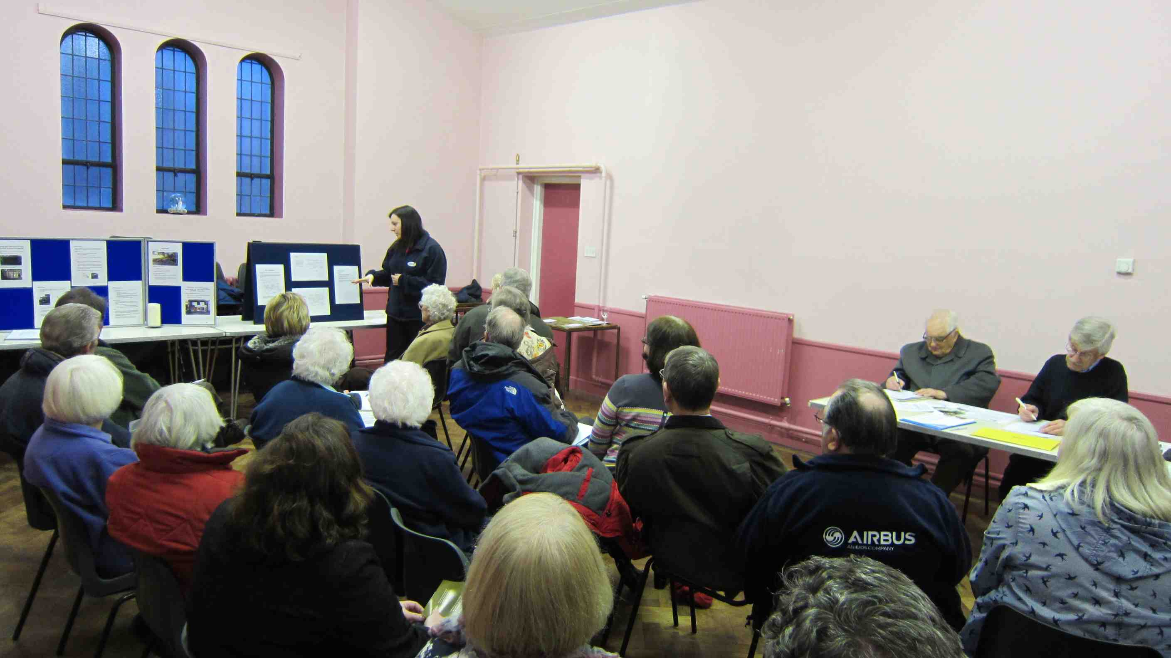 |  |  |  |  | 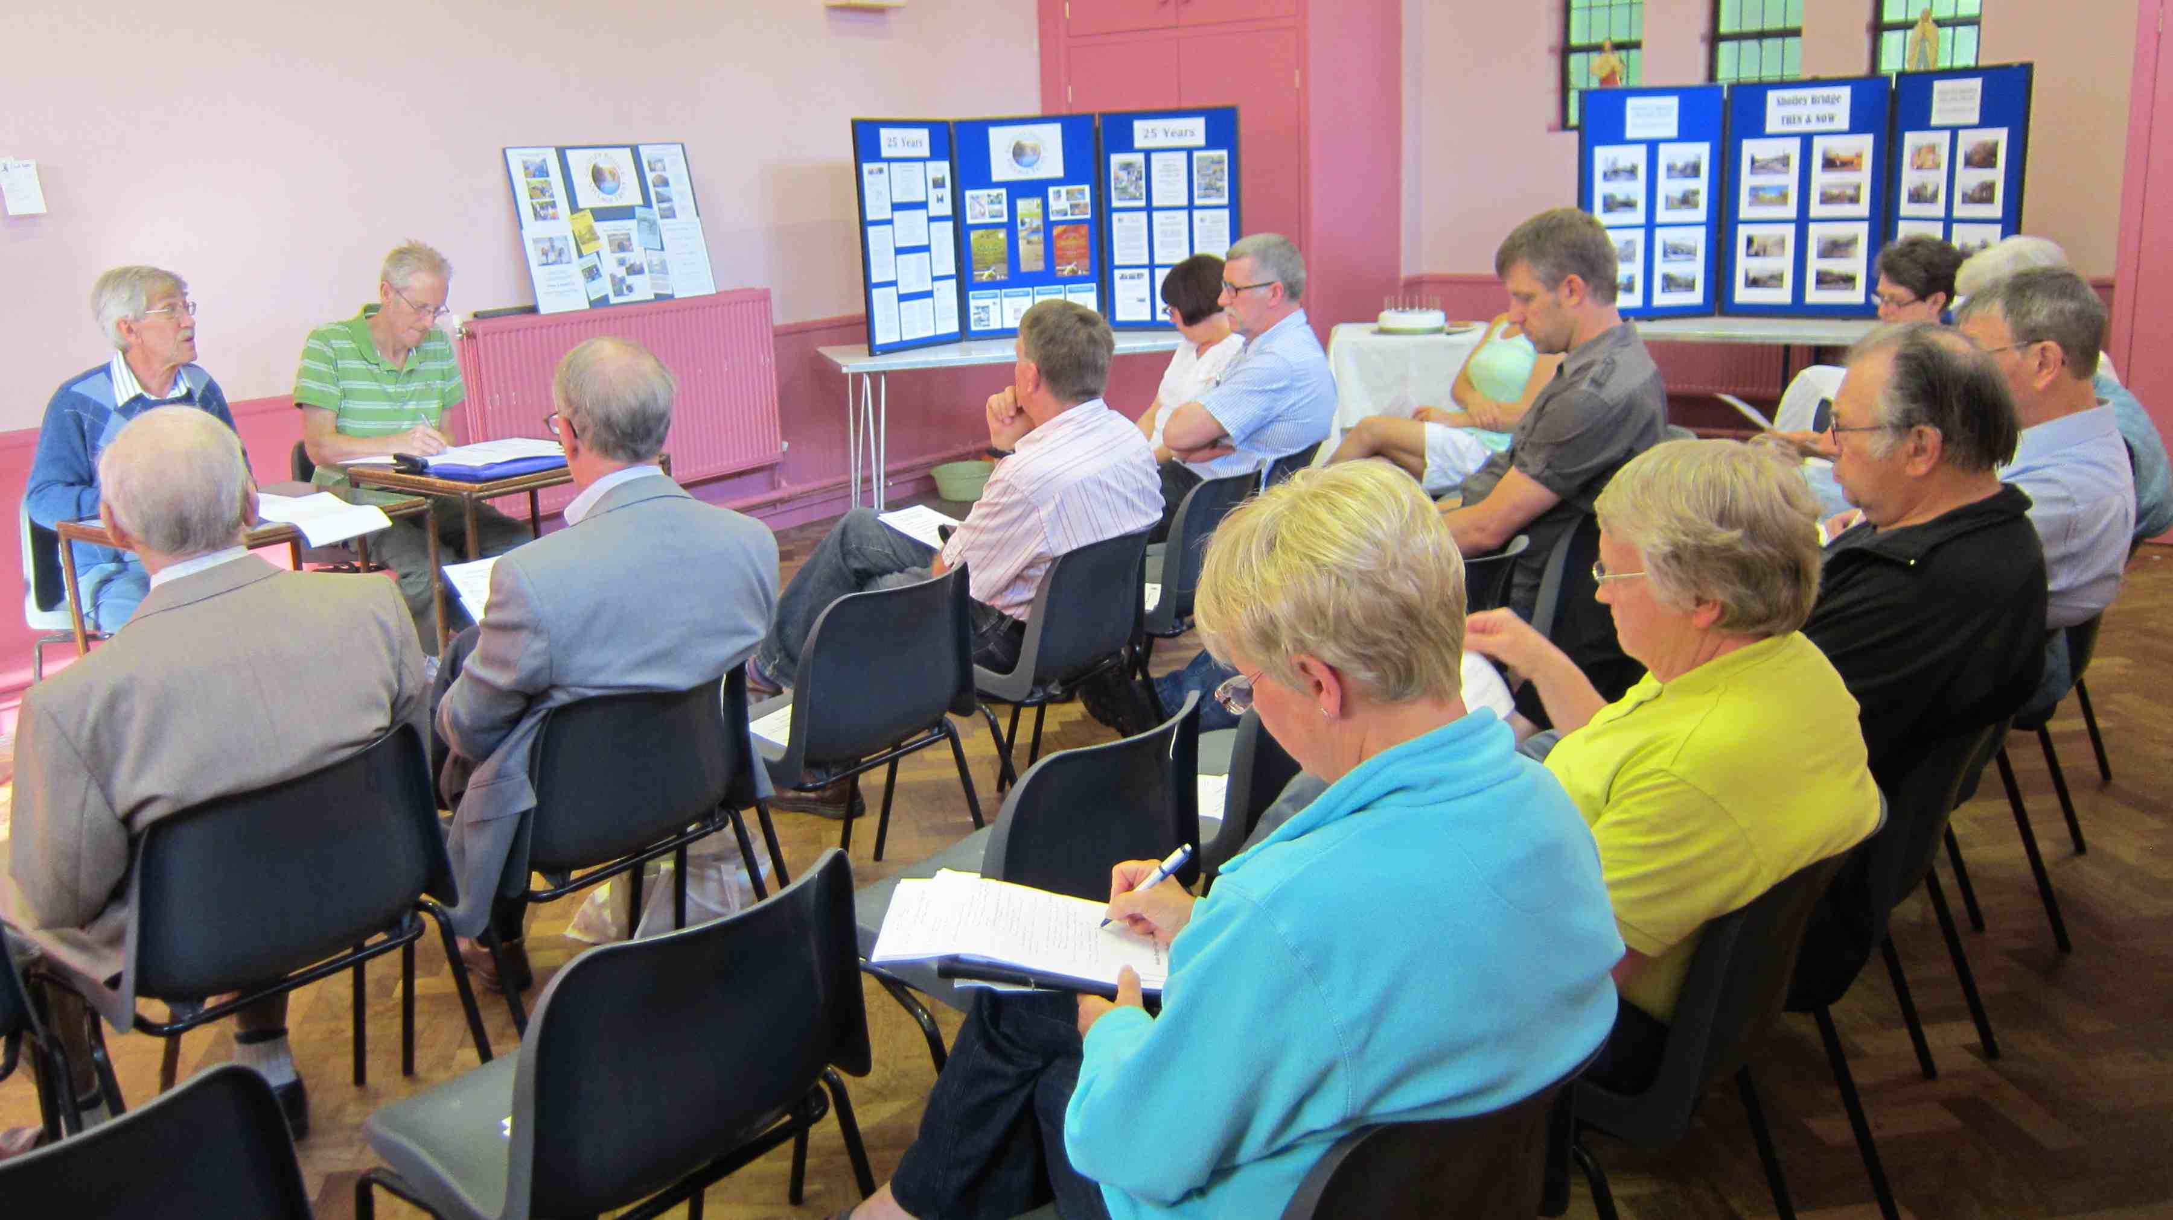
A separate business and residents’ newsletter about the ‘Best Hanging Basket’ competition, with other information about ‘Blooming Shotley Bridge’ are distributed to properties and businesses within the boundary. |  |  |  |  |  |  | C2
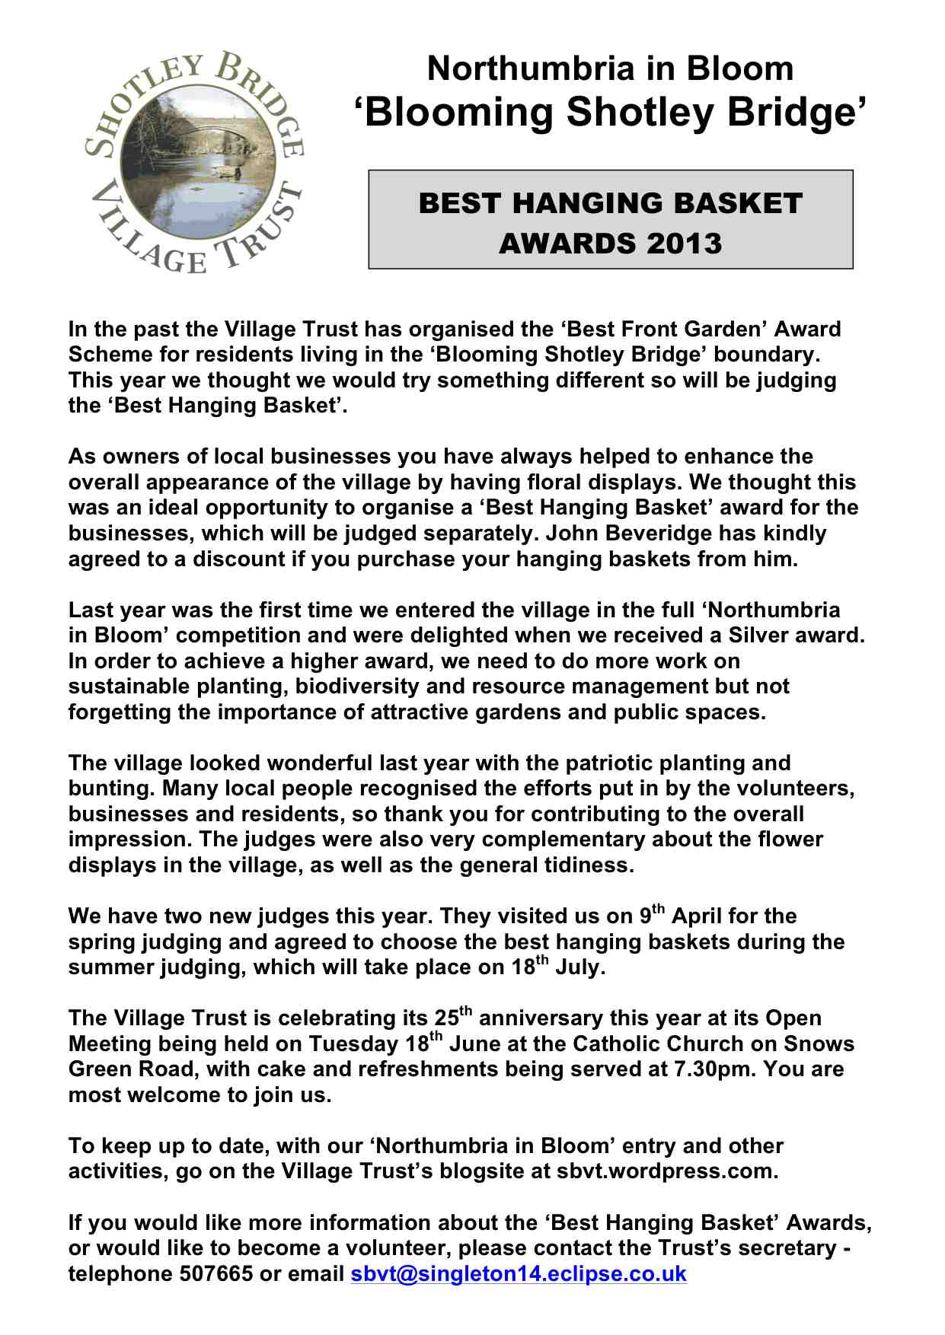 |  | 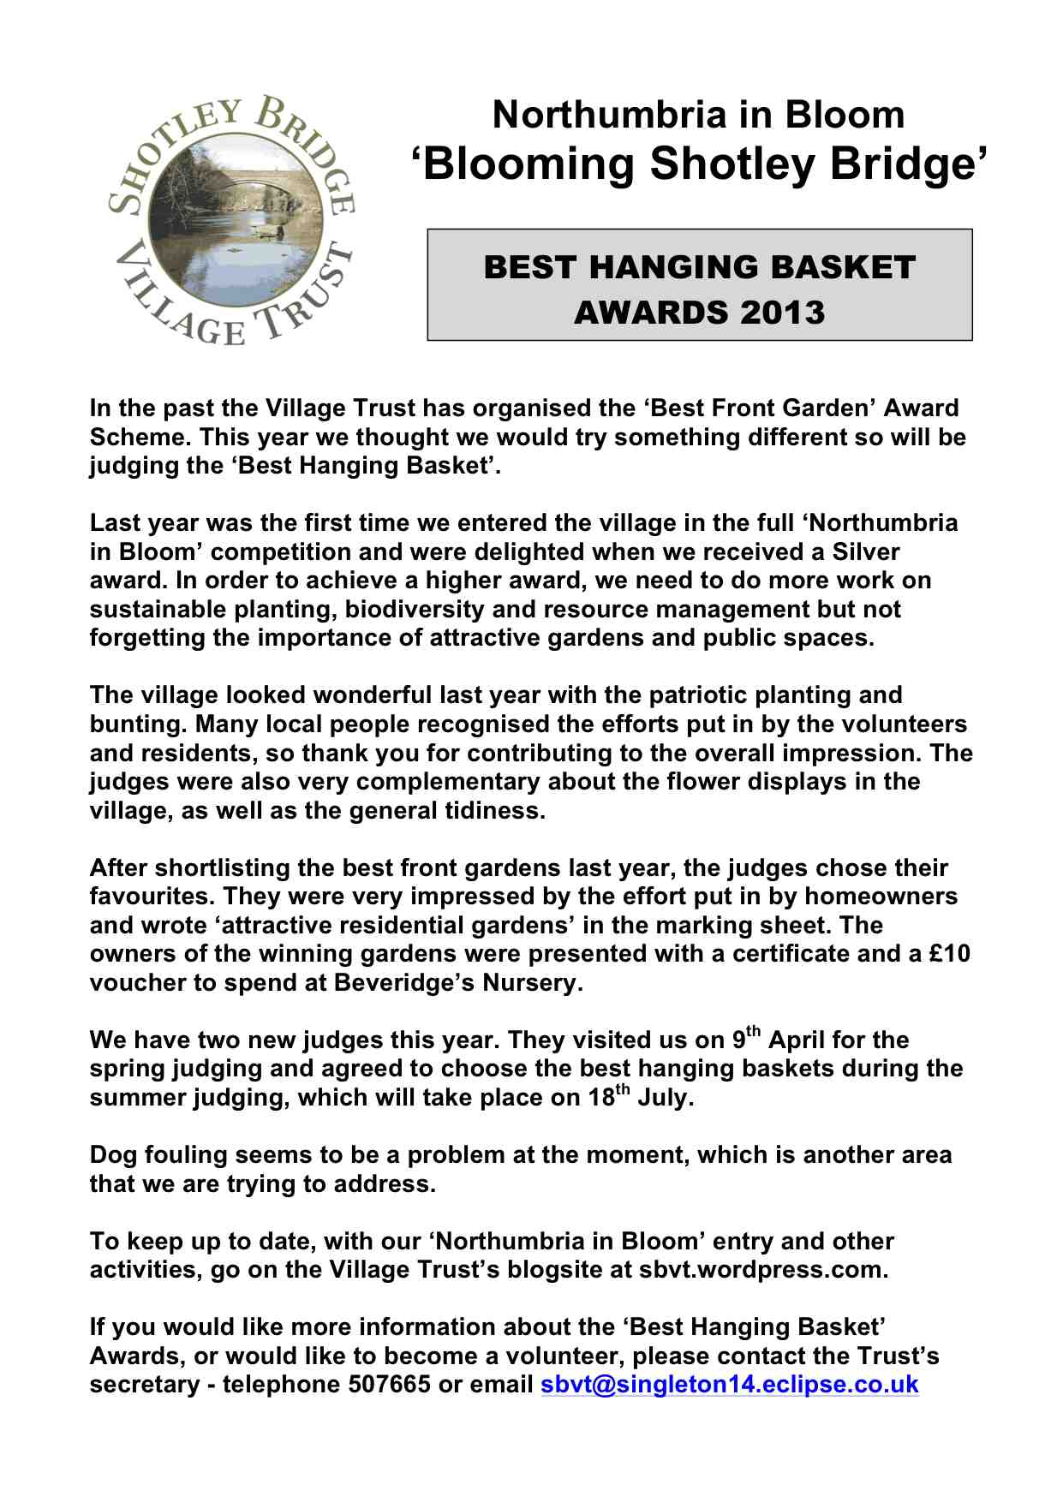
Emails to Village Trust members and volunteers are sent out on a regular basis, as and when required. |  |  |  |  |  |  | C2
The Village Trust blog/website is updated on a regular basis and keeps local people and those living further afield informed about ‘’Blooming Shotley Bridge’.
SBVT volunteers now also manage Facebook sites ‘Shotley Bridge - The Village ‘and’ Blooming Shotley Bridge, which were developed further this year.
Visits to schools and community groups. One of the projects in the past was to ask the children to produce a poster about picking up litter and cleaning up after your dog.

